Point cloud processing Journal

# Grottes des Faux Monnayeurs

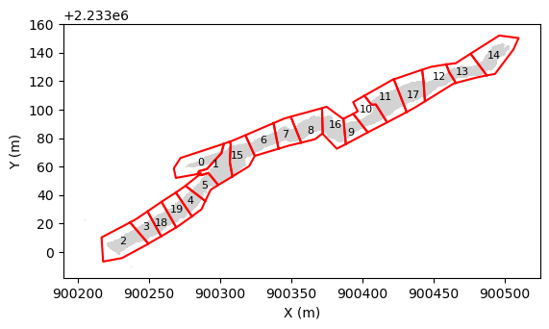

Summary

1. Georeferencing and sectionning in 20 segments with python code D:\CloudComPy310_20230705\CloudComPy310\process 09_SegmentCloudFromShapefile.ipynb
2. Point cleaning and normal calculation manually by Celia on Cloud Compare
   1. Canopy classifier: D:/ScanLeica/ people_bedrock_classifier_10082023_strict_on_bedrock,
      1. “subsample cloud = 0.05
   2. Connex composant
      1. Octree level 0.08 (8cm), except chunks 9 and 15 (Octree level of 4cm)
      2. Min. points per component = 10
   3. Normal computing
      1. Local surface model = Plane,
      2. Octree radius à 0.08
      3. Orientation Use minimum Spanning Tree = knn  = 12
3. Hand cleaning of operators: Chunk 2 and 6 before Connexe composant

## 08.09.2023

Tanguy ran the jupyter code to segment the cave. And saved 20 segement in D:\ScanLeica\GrotteDesFauxMonnayeurs\process

## 11.09.2023 - Point cloud leaning, and normal calculations

Following protocol set by Tanguy: cleaning operator and other misc points.

1. Classify operators vs cave with the plugin canopy classify using people_bedrock_classifier_10082023_strict_on_bedrock.prm trained by Tanguy on …

### Cropped 2:

Pas sur que ça a bien nettoyé l’operateur sur celui là.

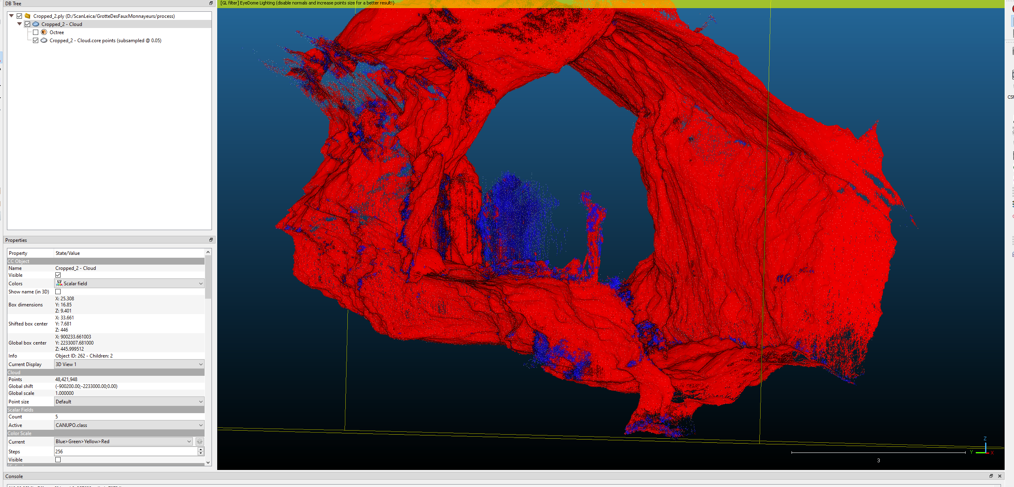

Nope, cropped 2 ça a pas trop marché.

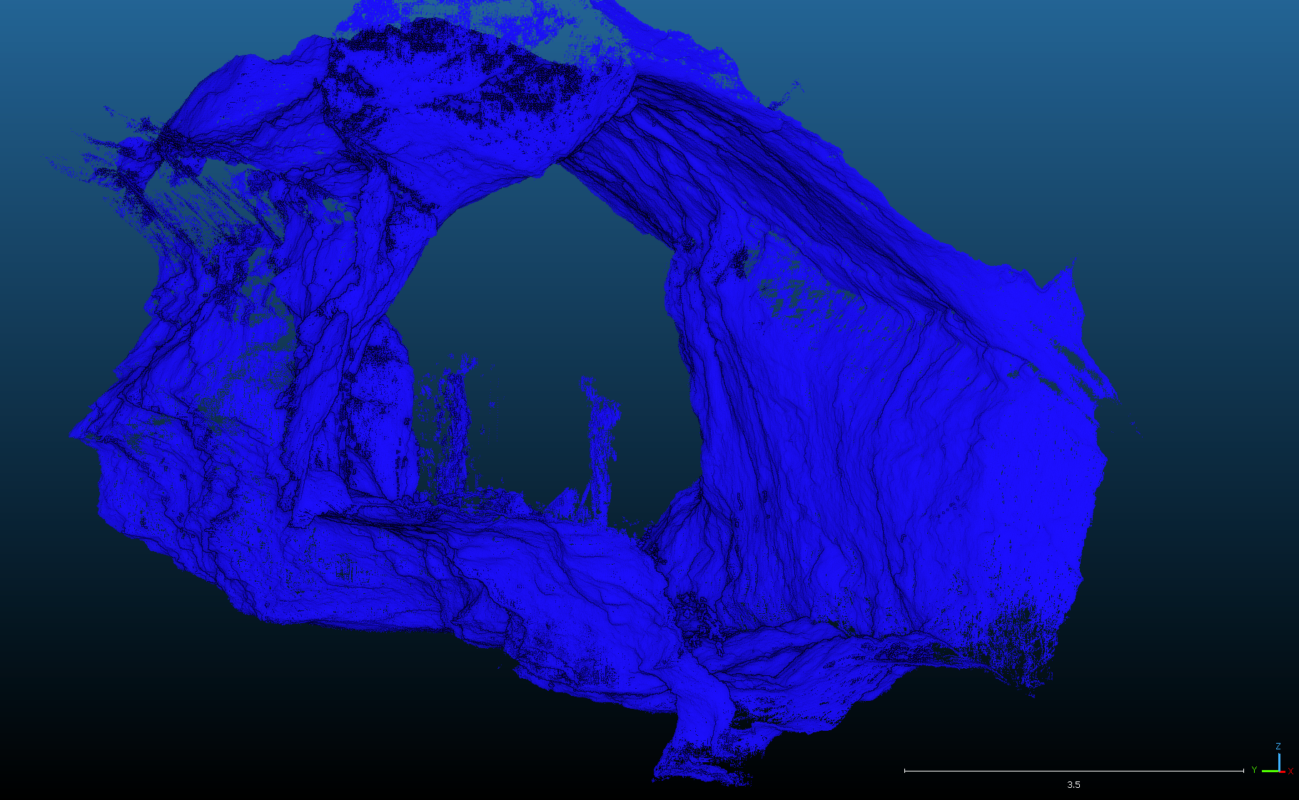

### Cropped 3

Déjà fait Vendredi passé par Tanguy. Pas eu besoin du classificateur

### Cropped 4

Le classificateur canopy semble bien marcher. Sur la figure on voit que l’opérateur à bien été selectionner:

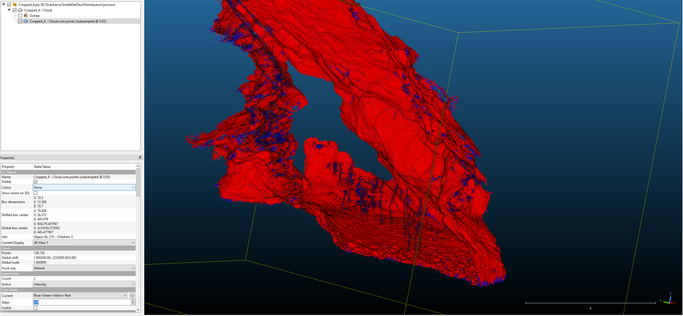

Après la classification, est-ce que les petit “vers de terre de point” vont poser un probleme??

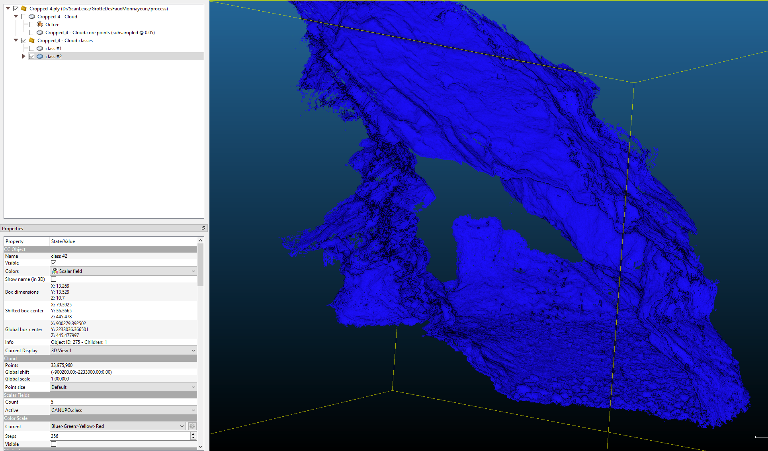ap

Après l’etape cccc, il reste quelques ver de terre

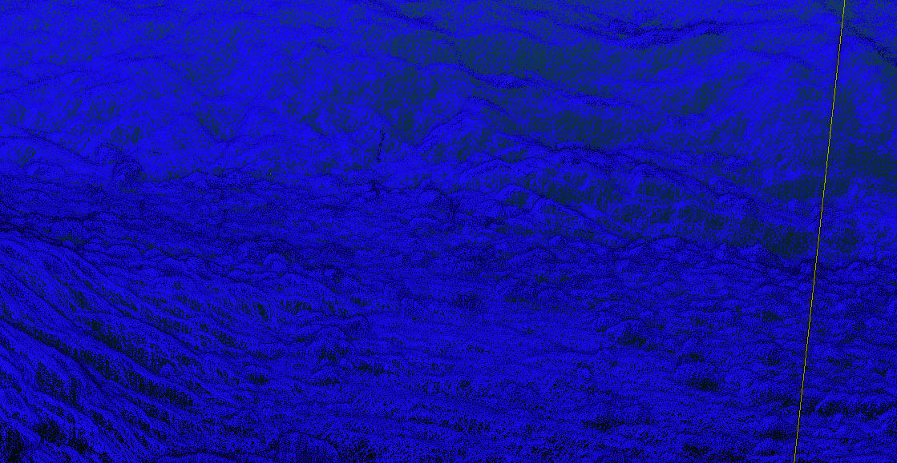

### Cropped 5

Ça a l’air bon

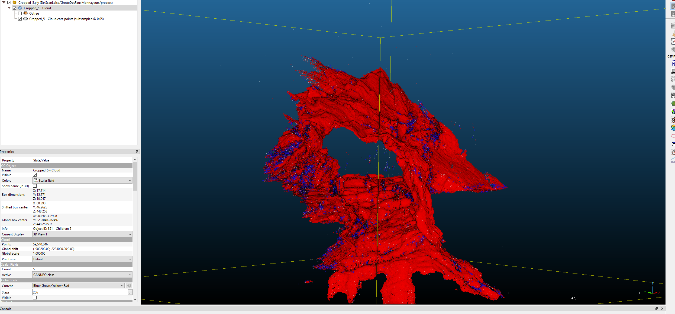

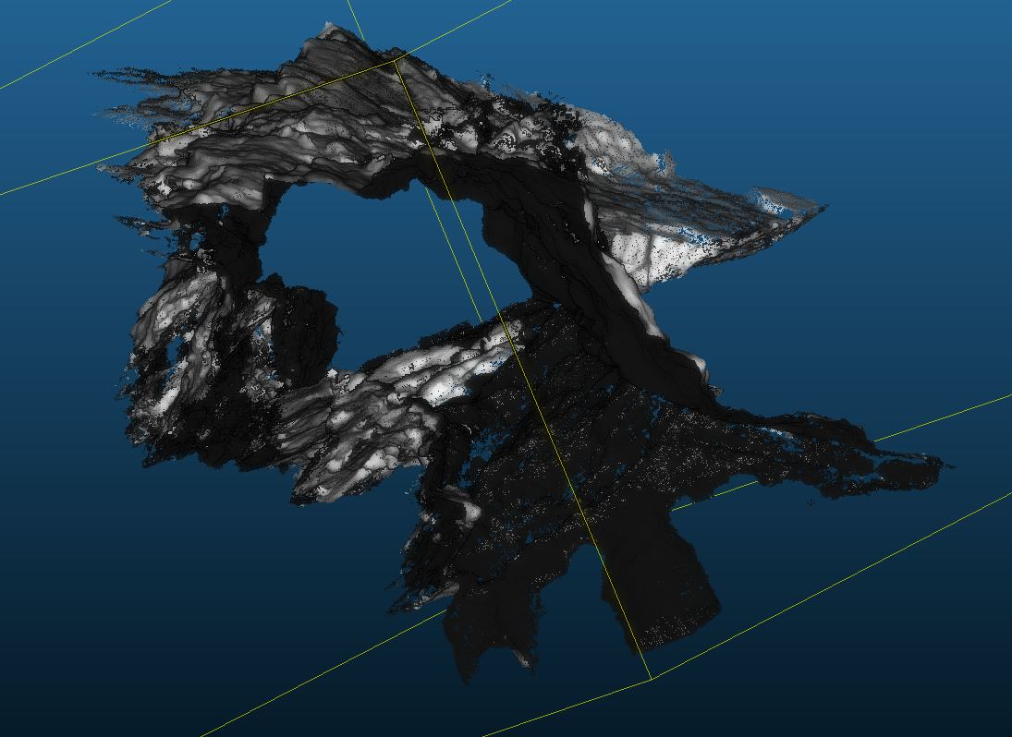

### Cropped 6

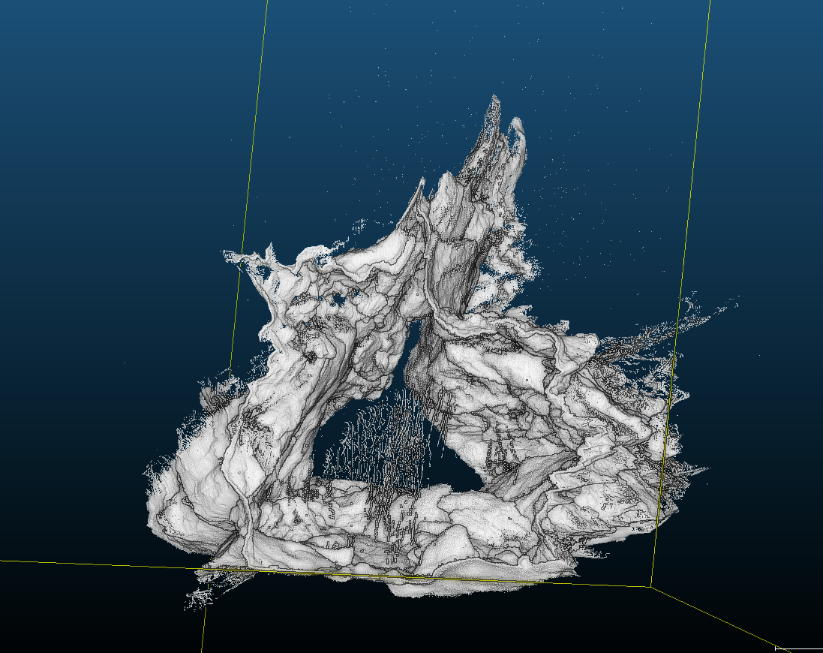

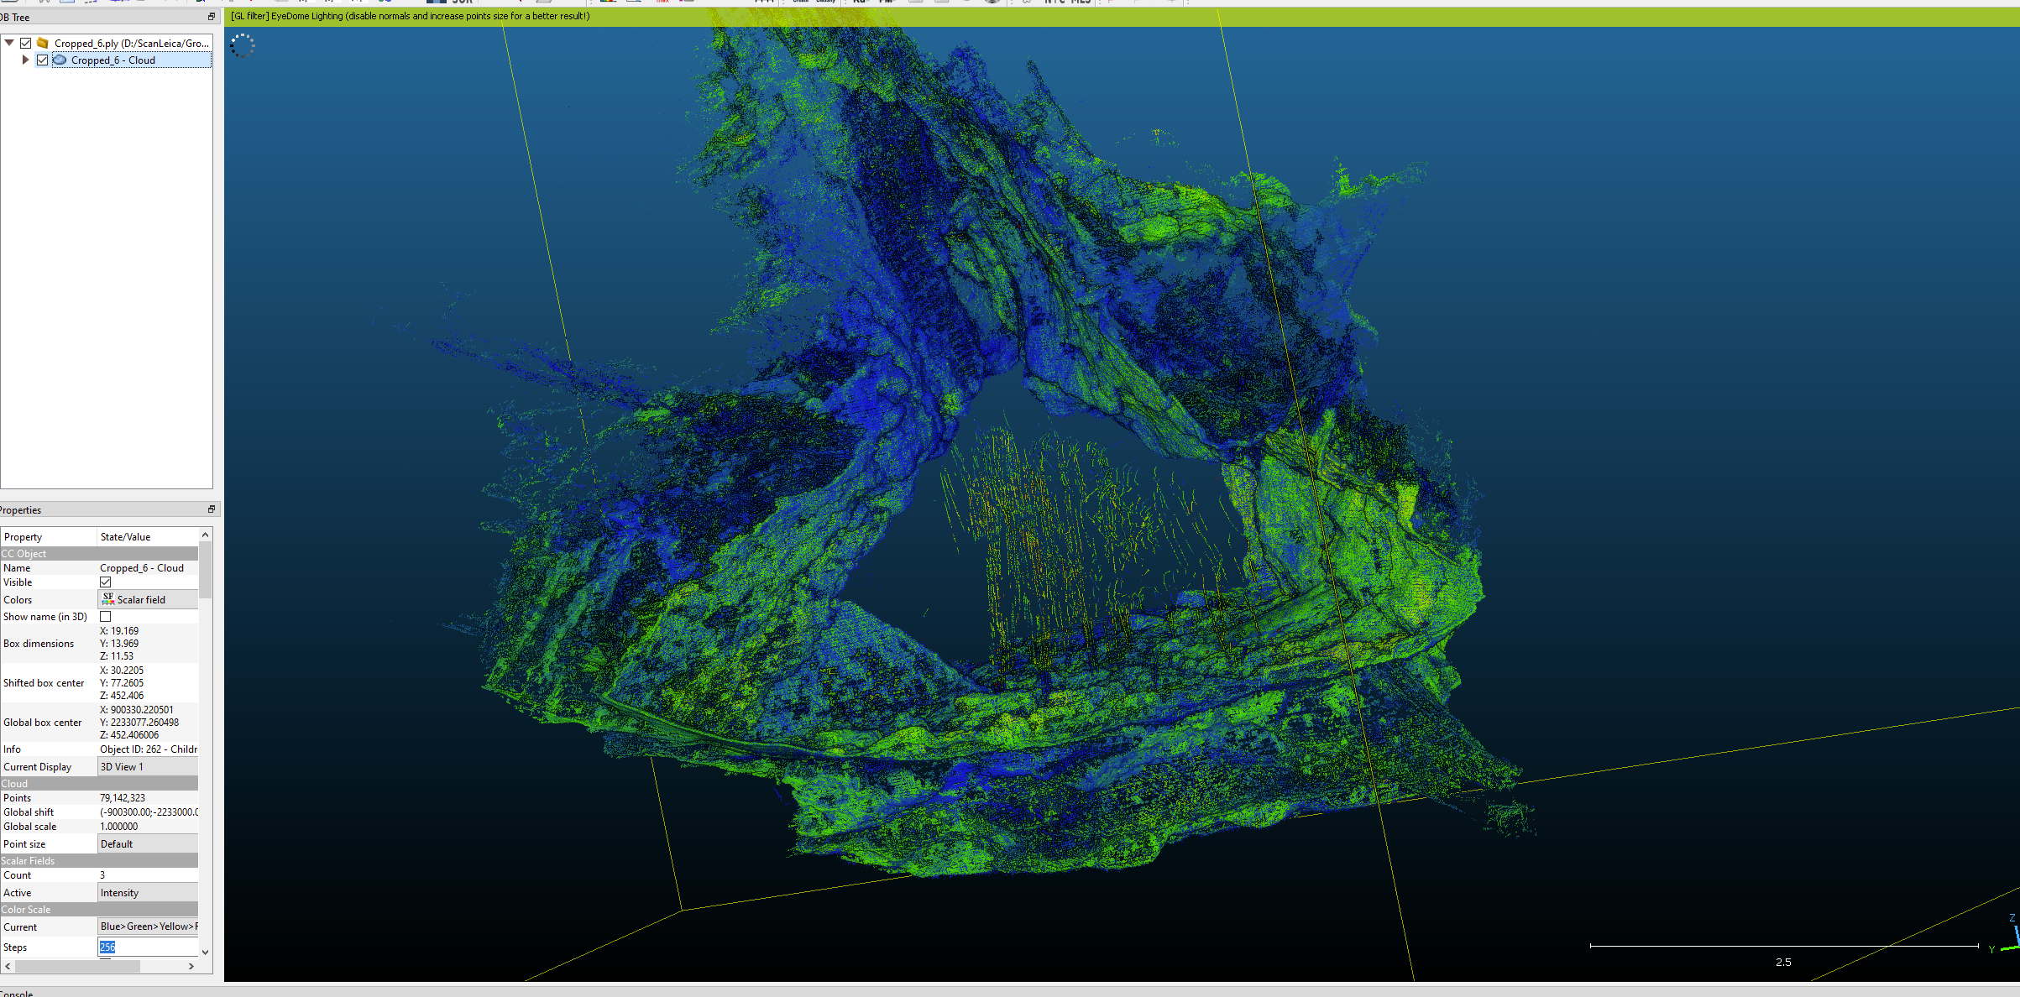

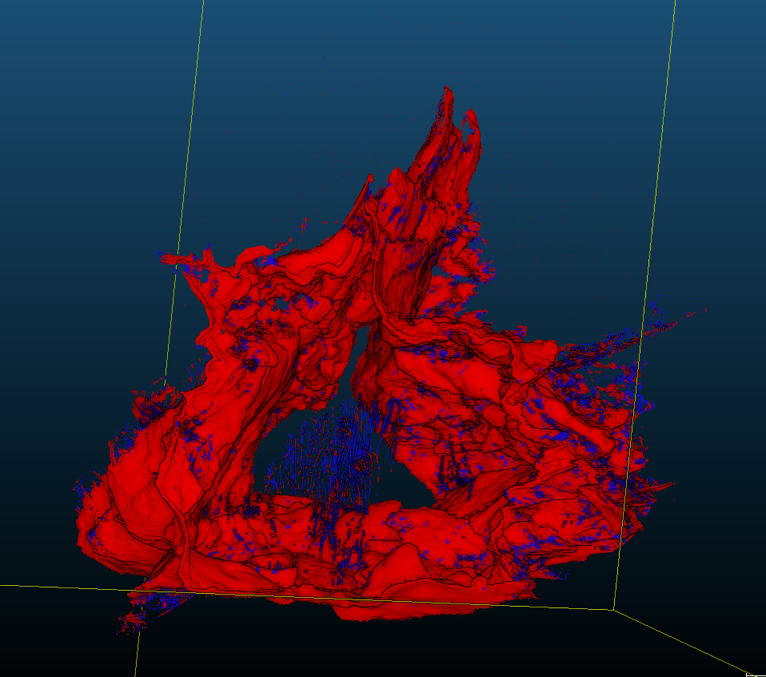

Problem pour celui là. Il reste de l’opérateur...

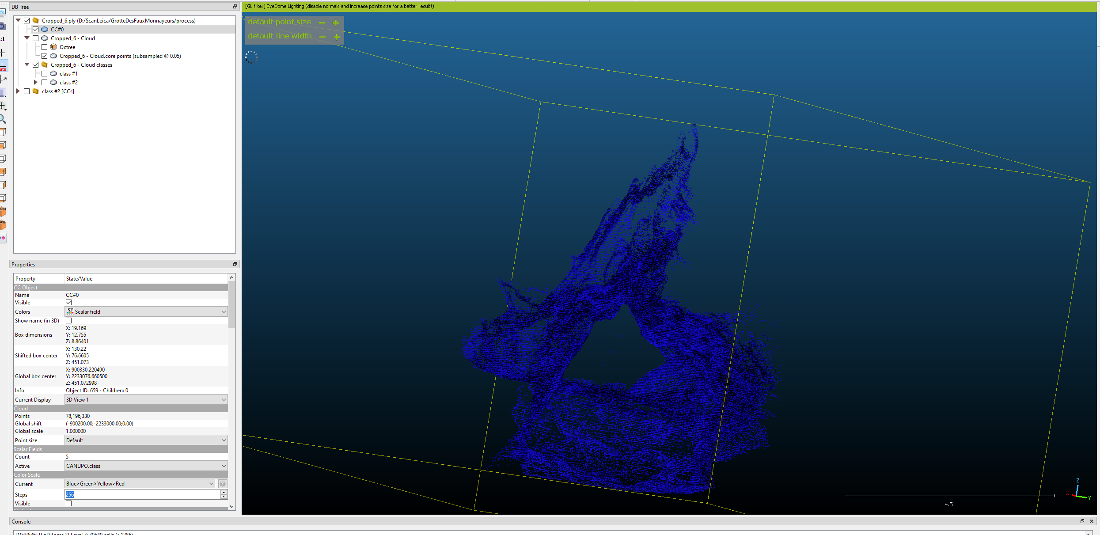

### Cropped 7

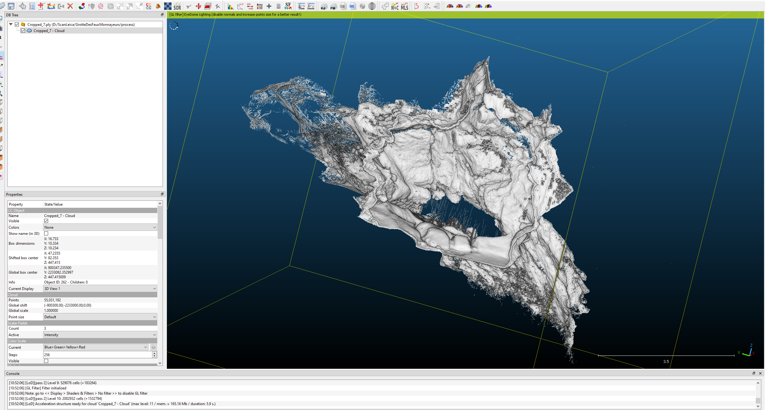

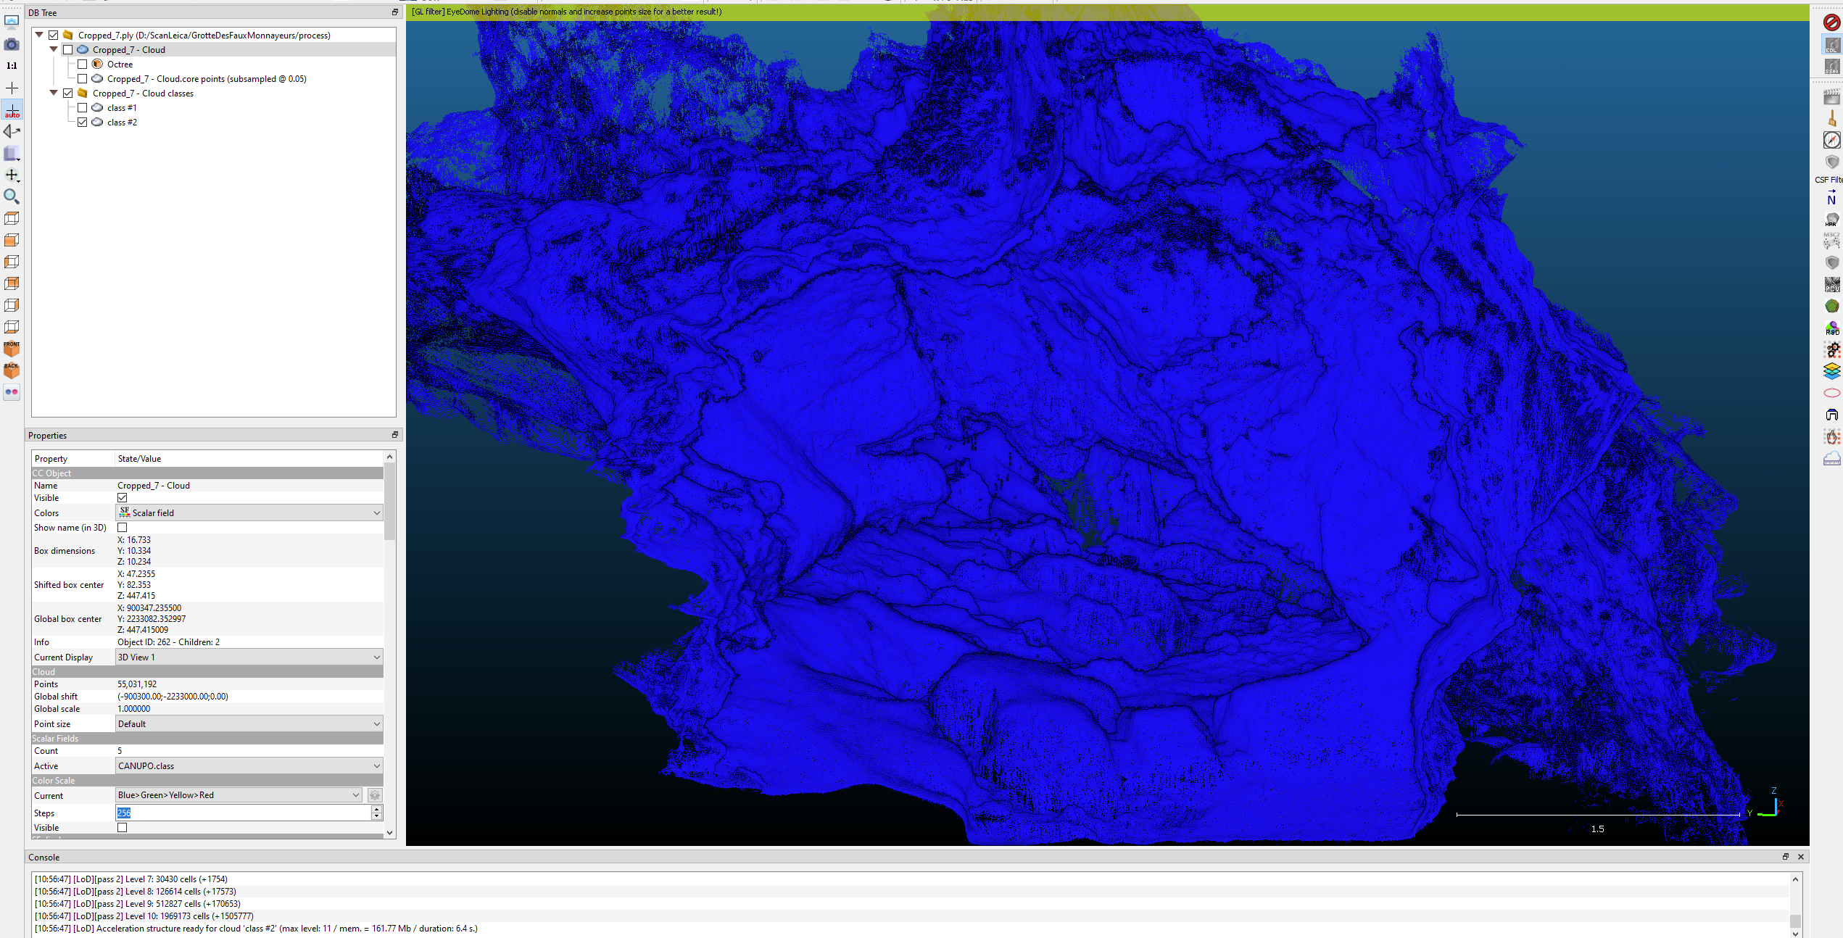

En general pas mal, mais reste quand même quelques petits vers.

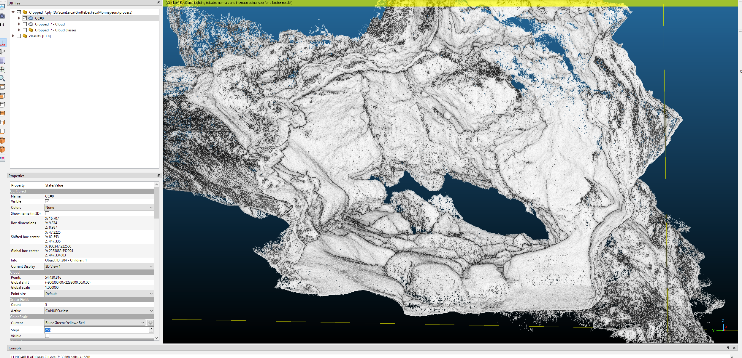

### Cropped 8

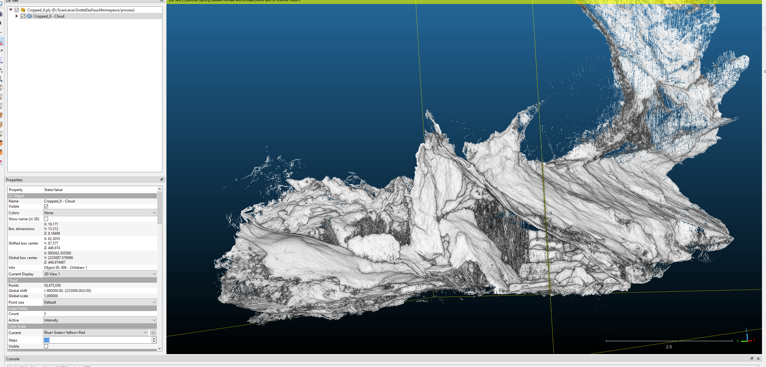

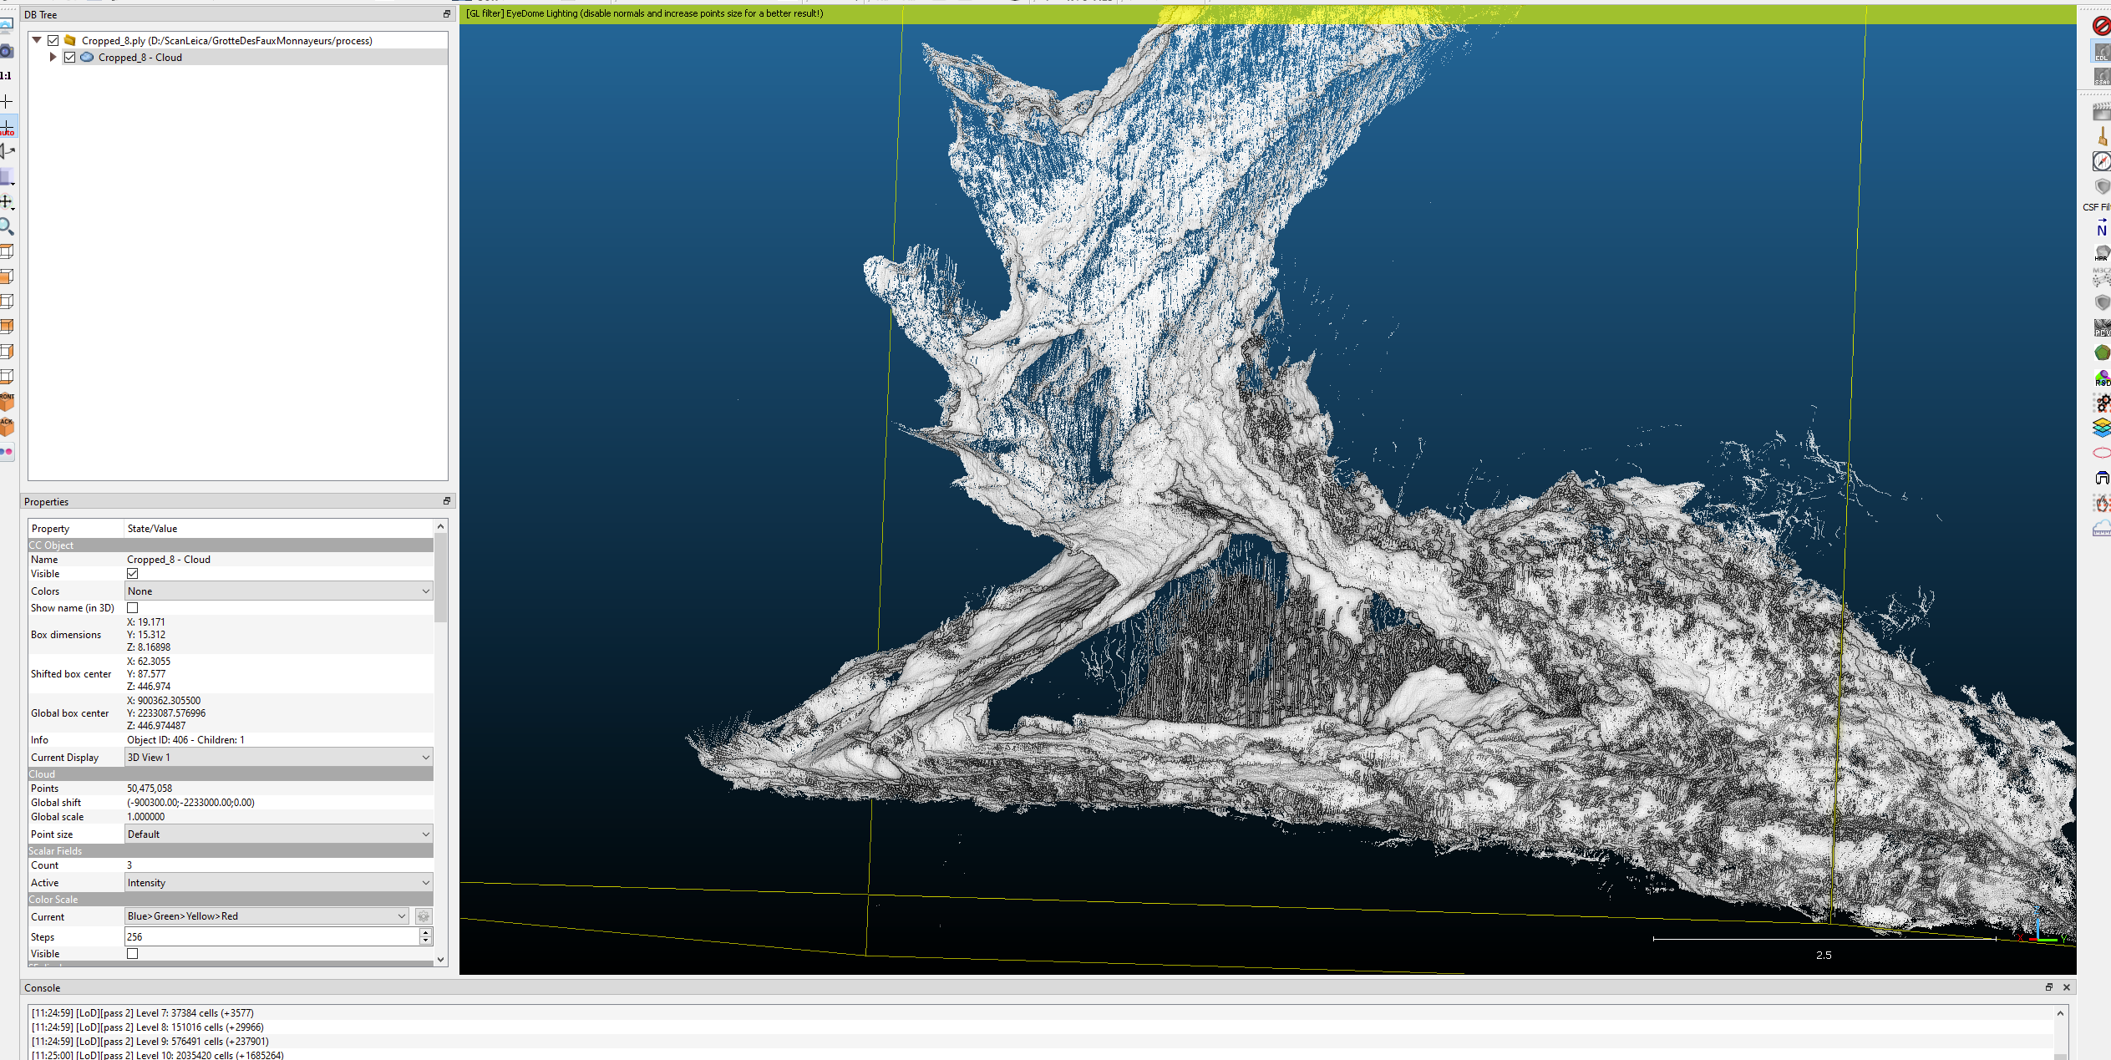

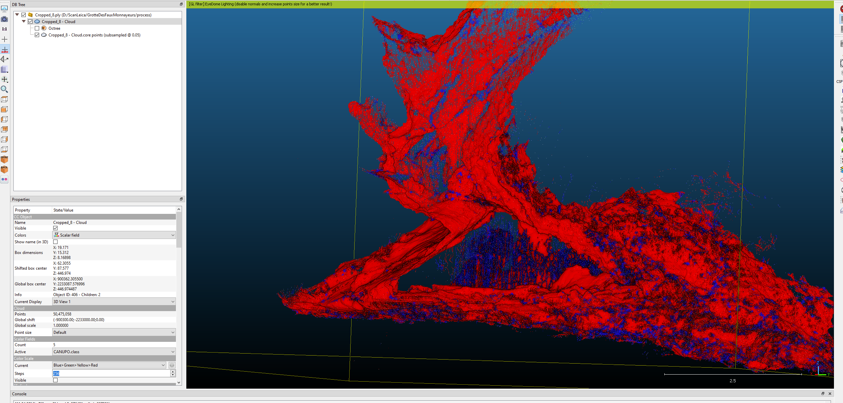

### Cropped 9

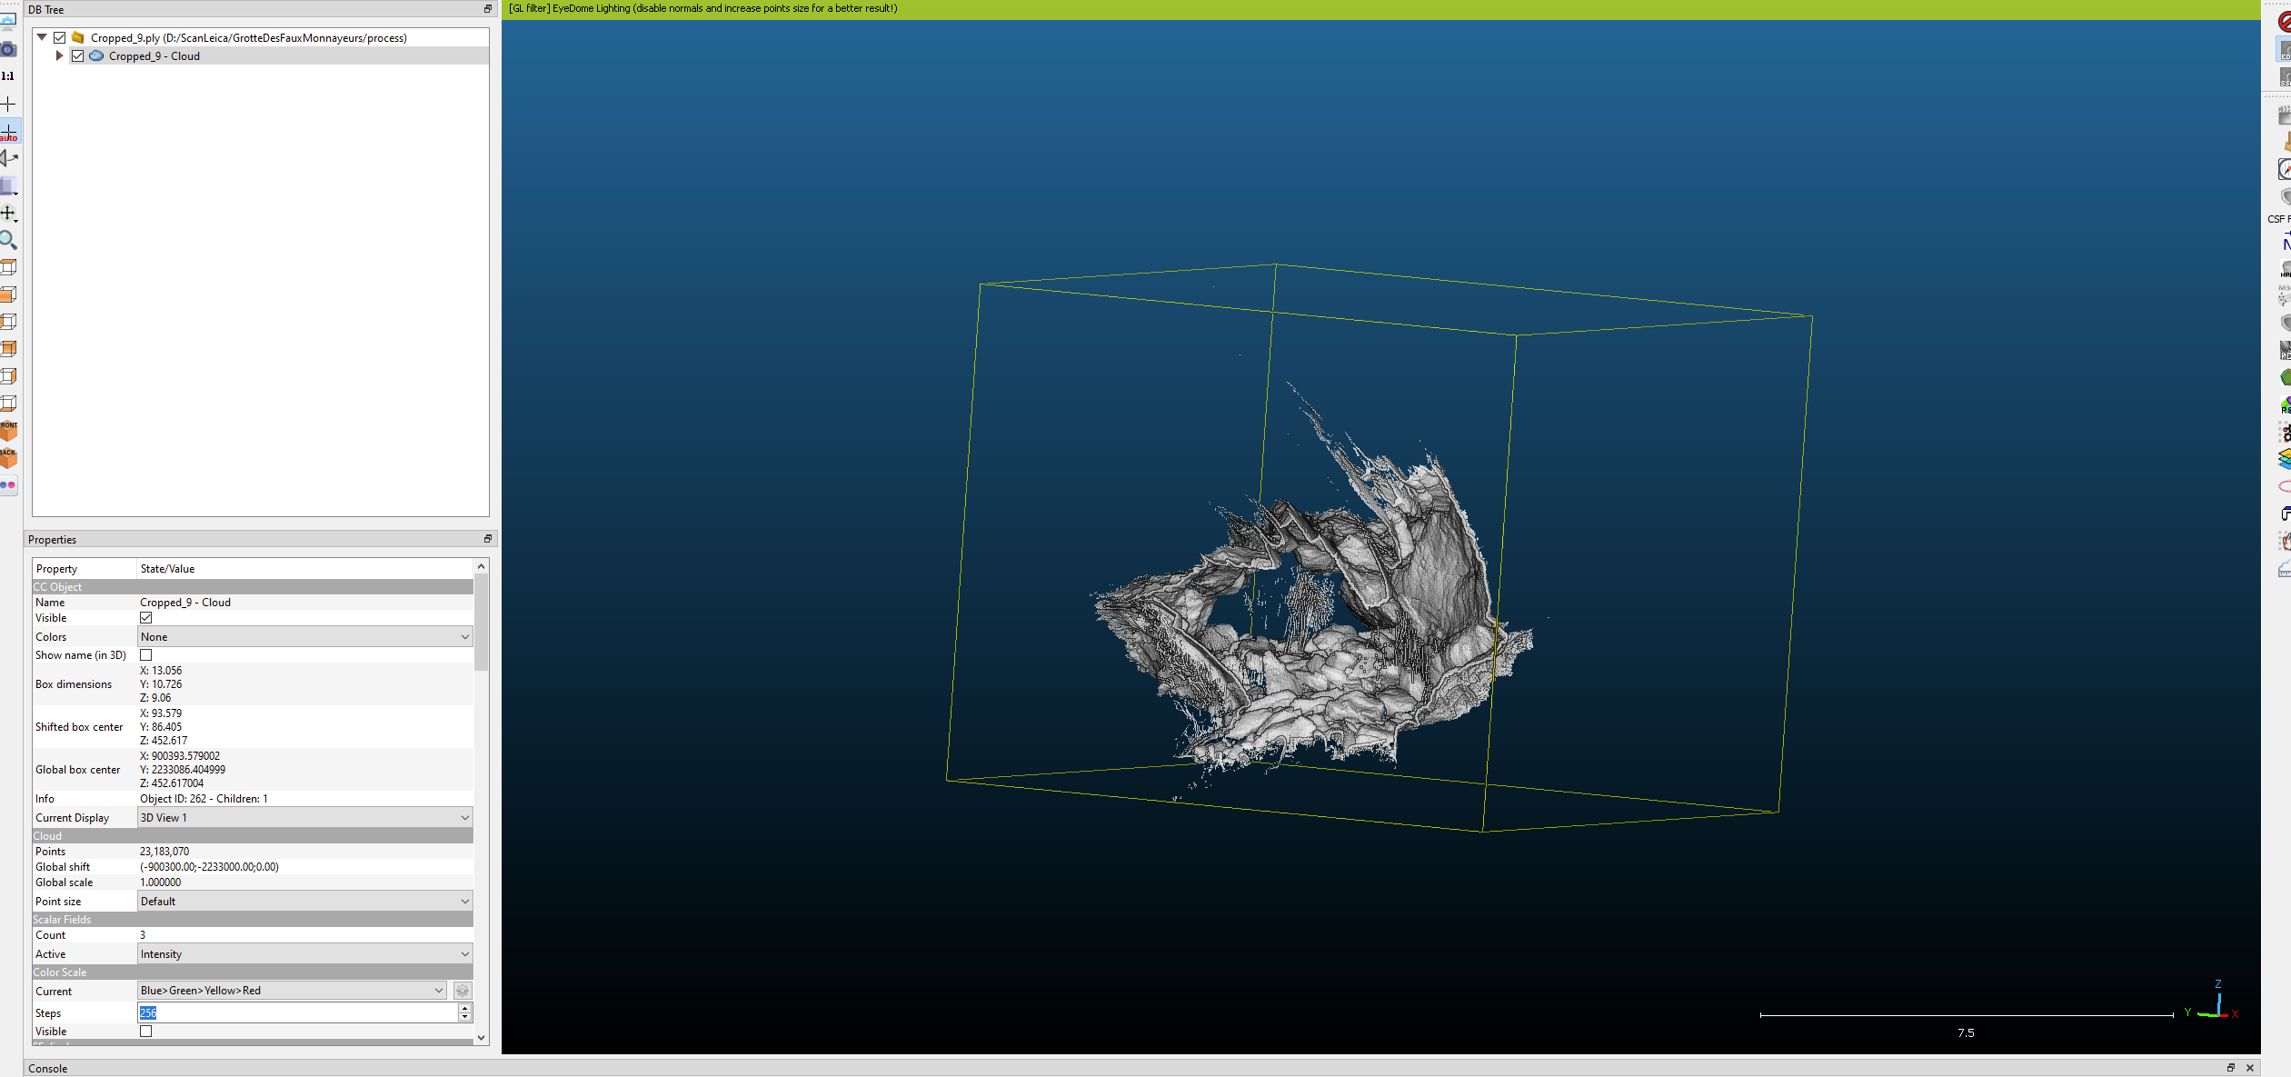

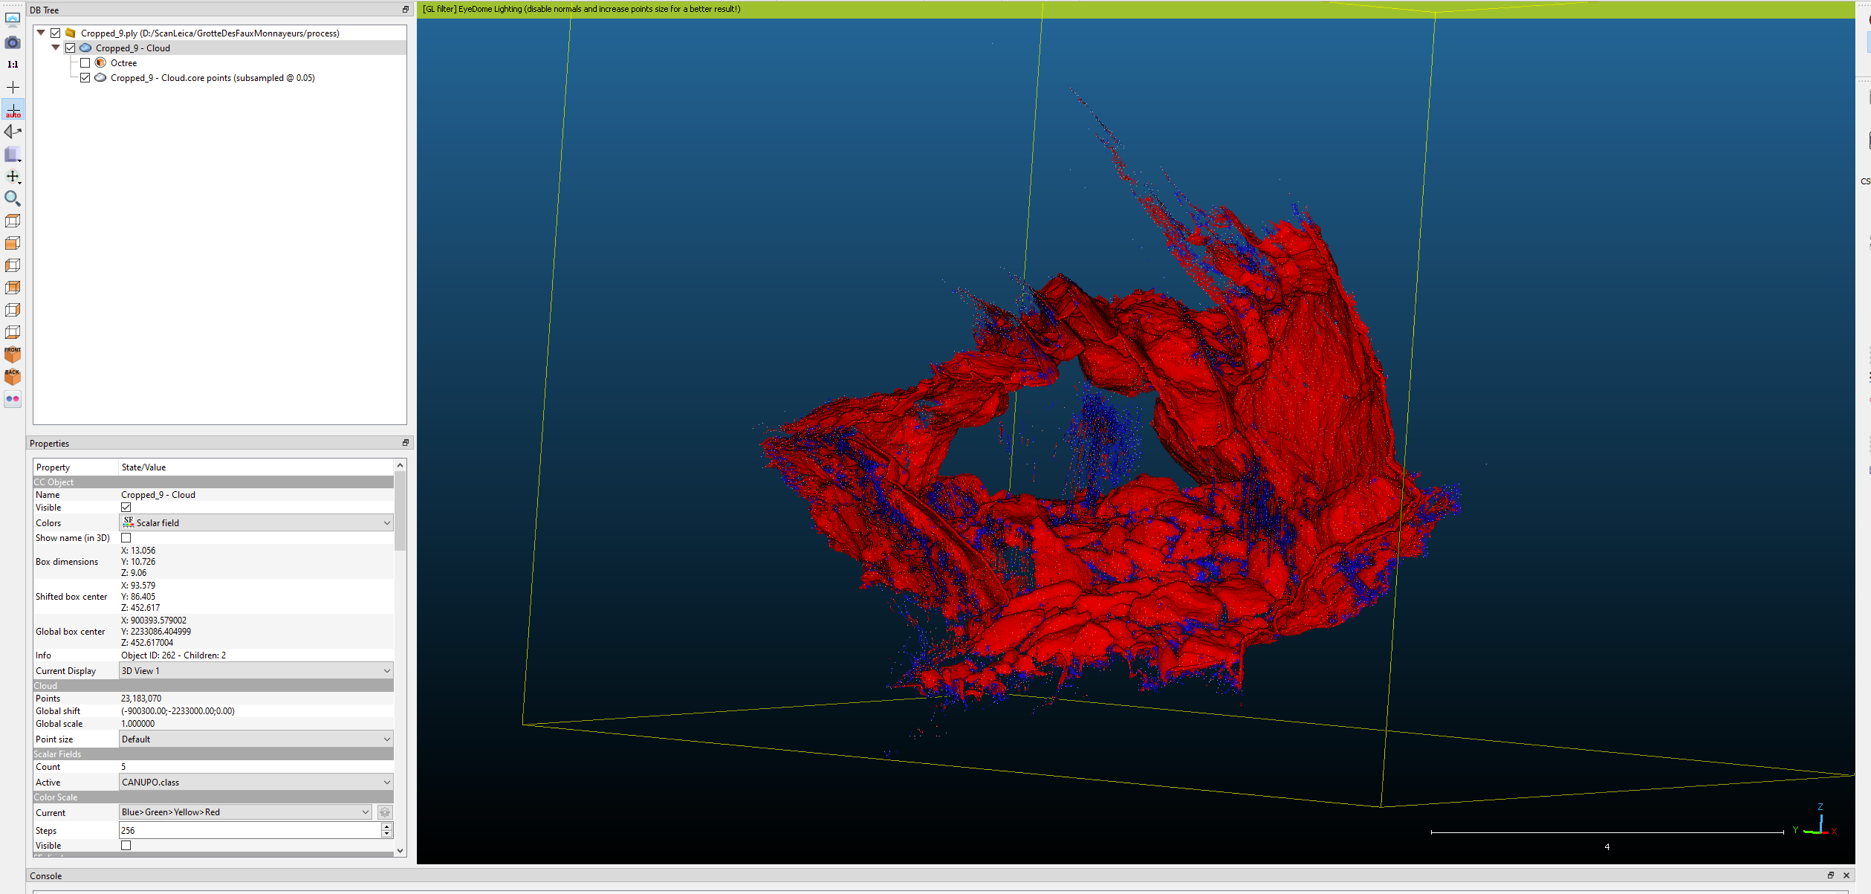

Il reste un petit bout d’operateur après le cccc

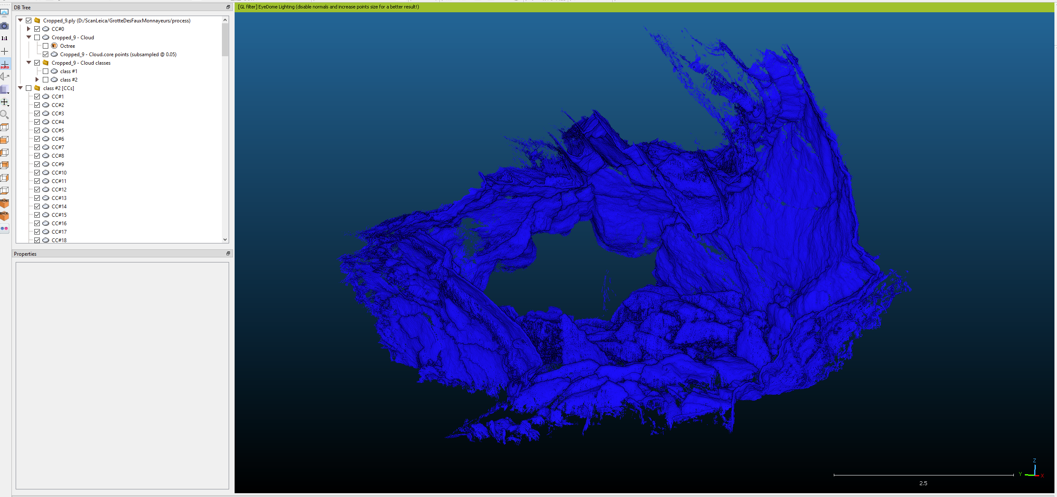

### Cropped 10

Not bad

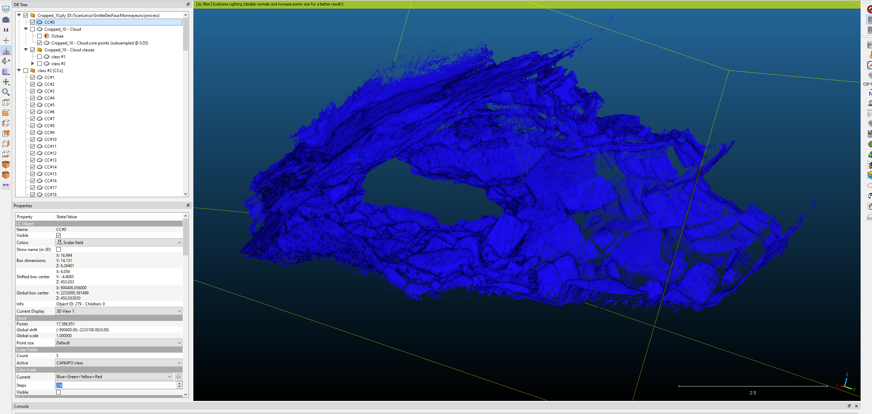

### Cropped 11

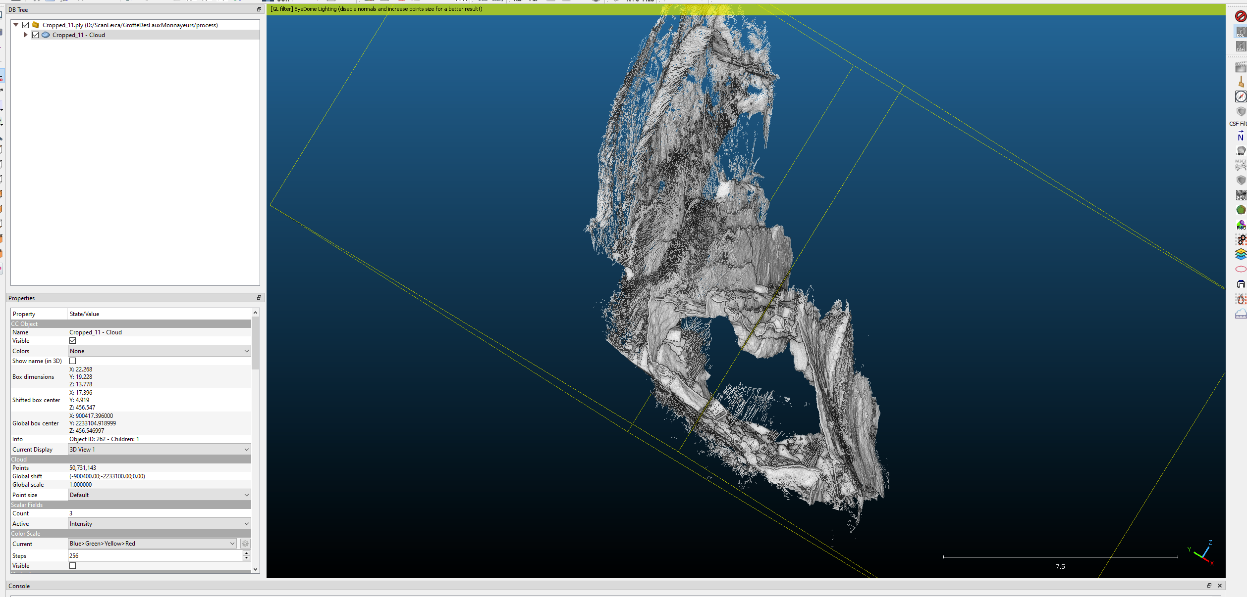

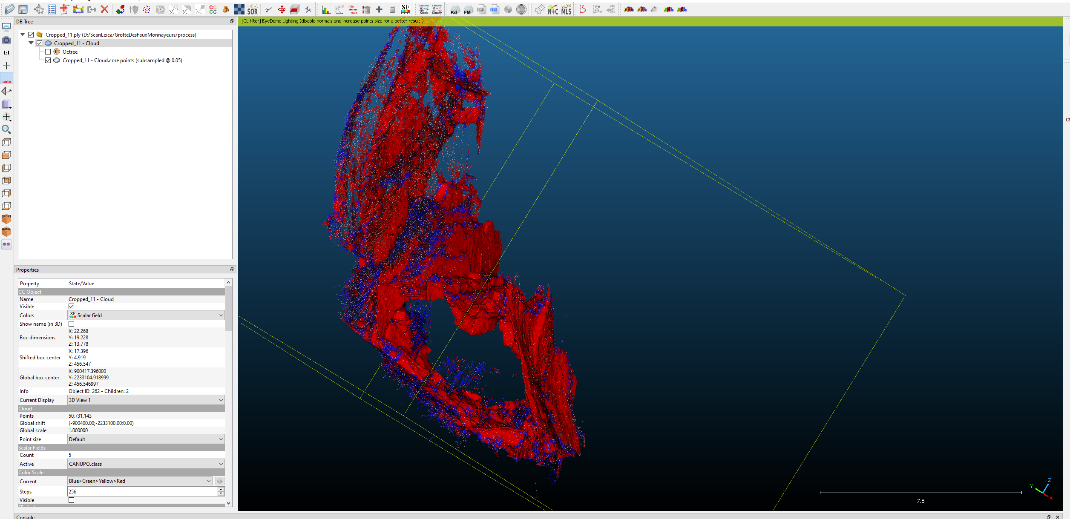

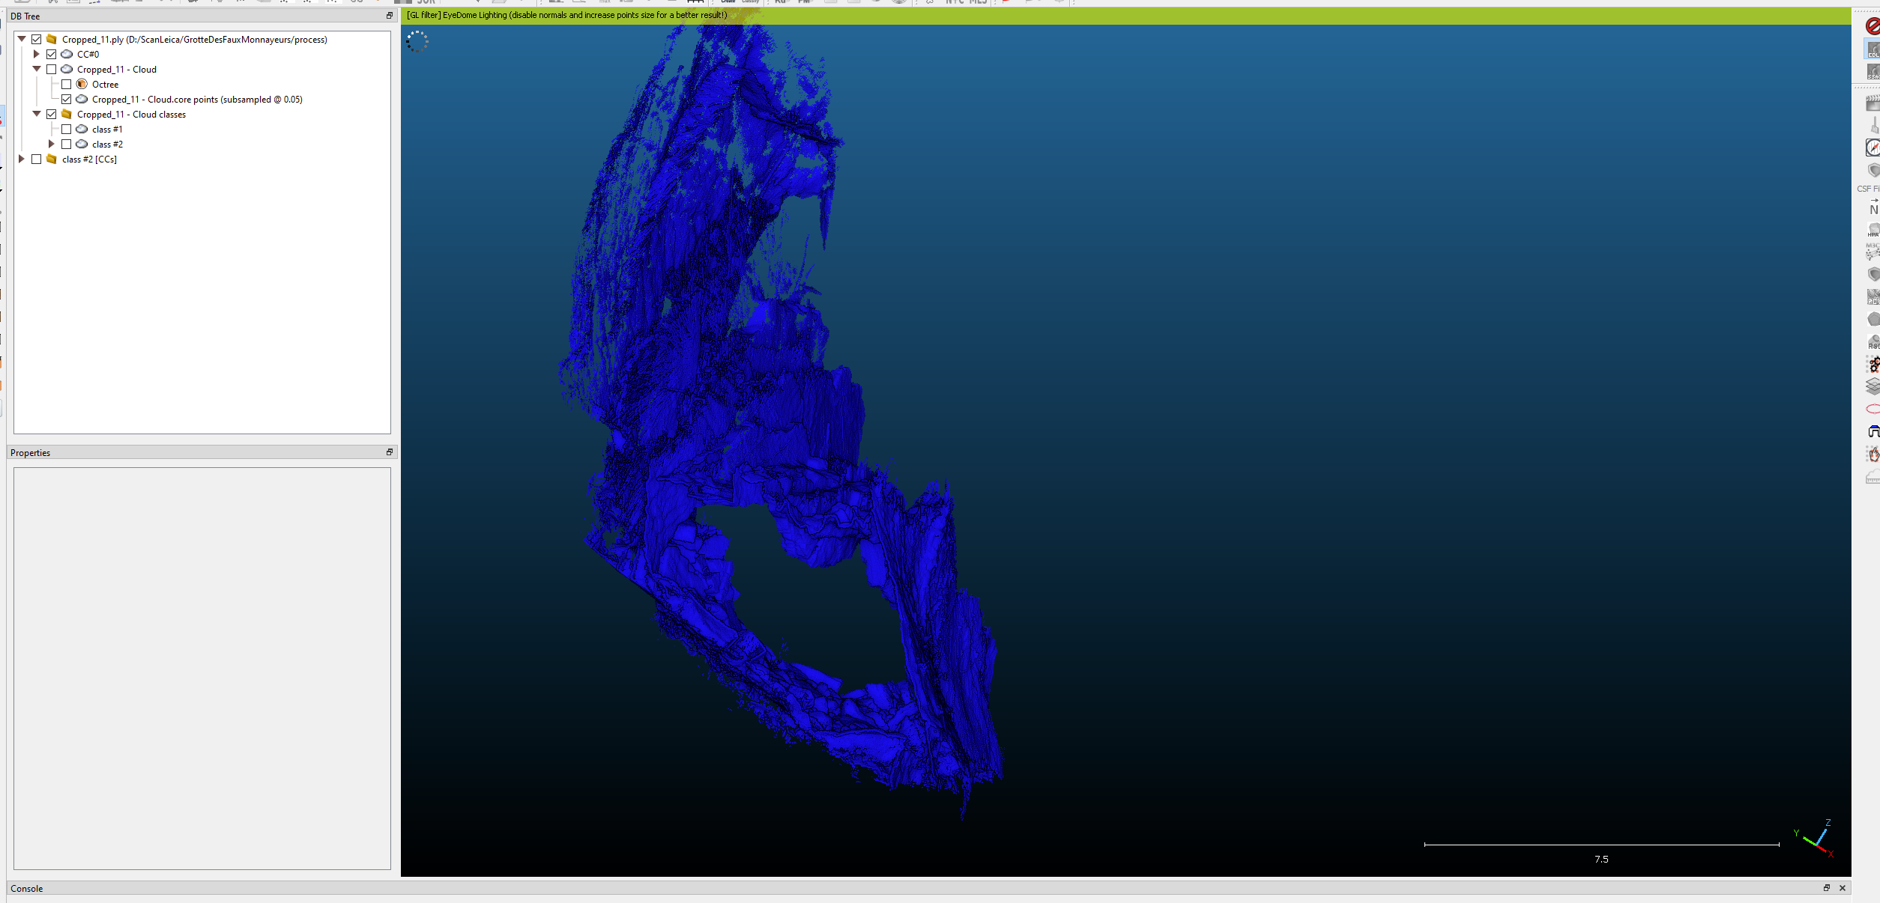

### Cropped 12

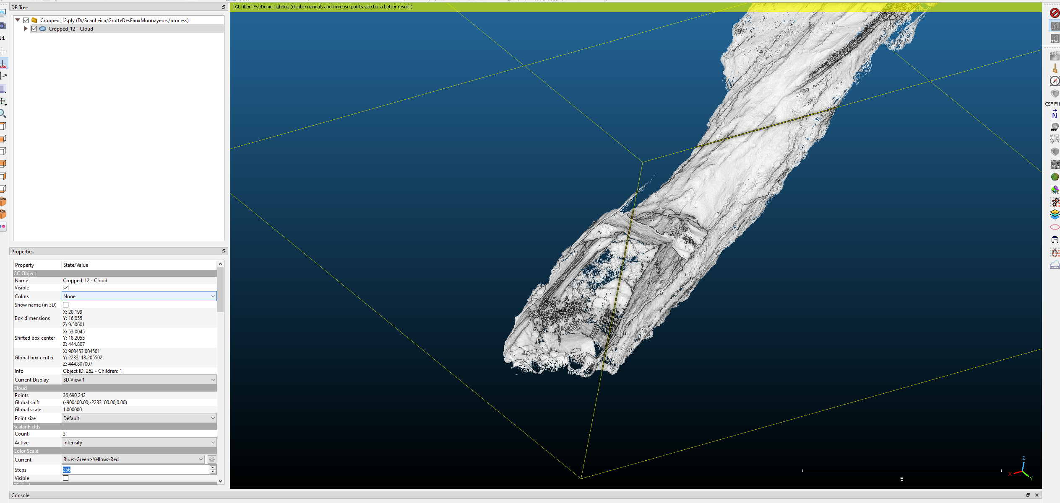

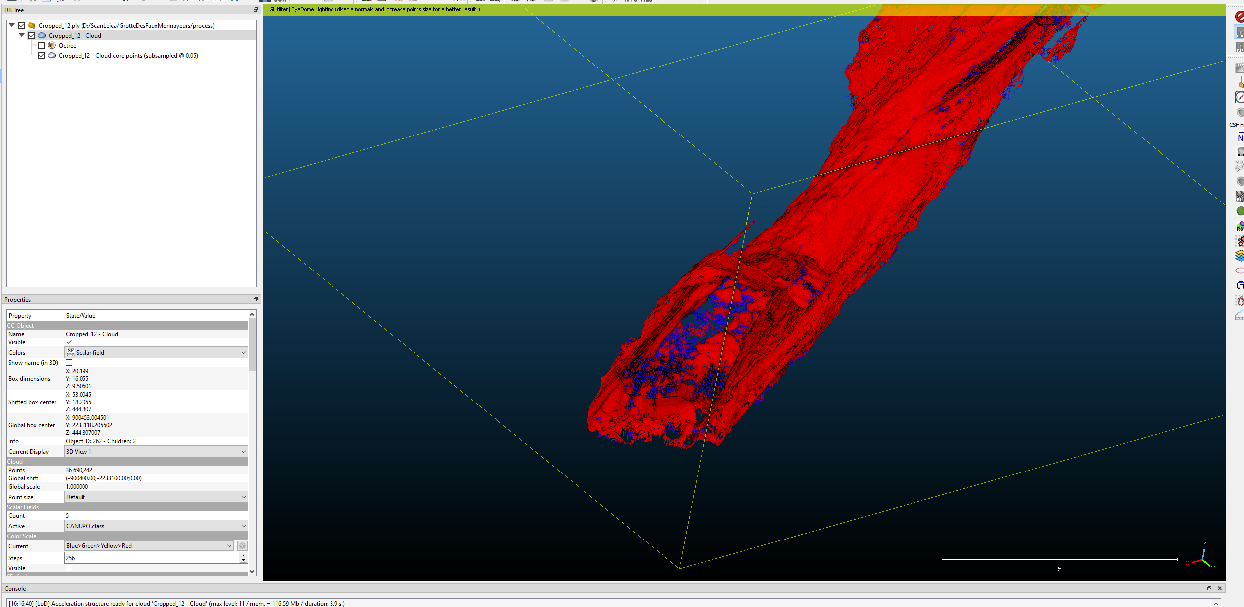

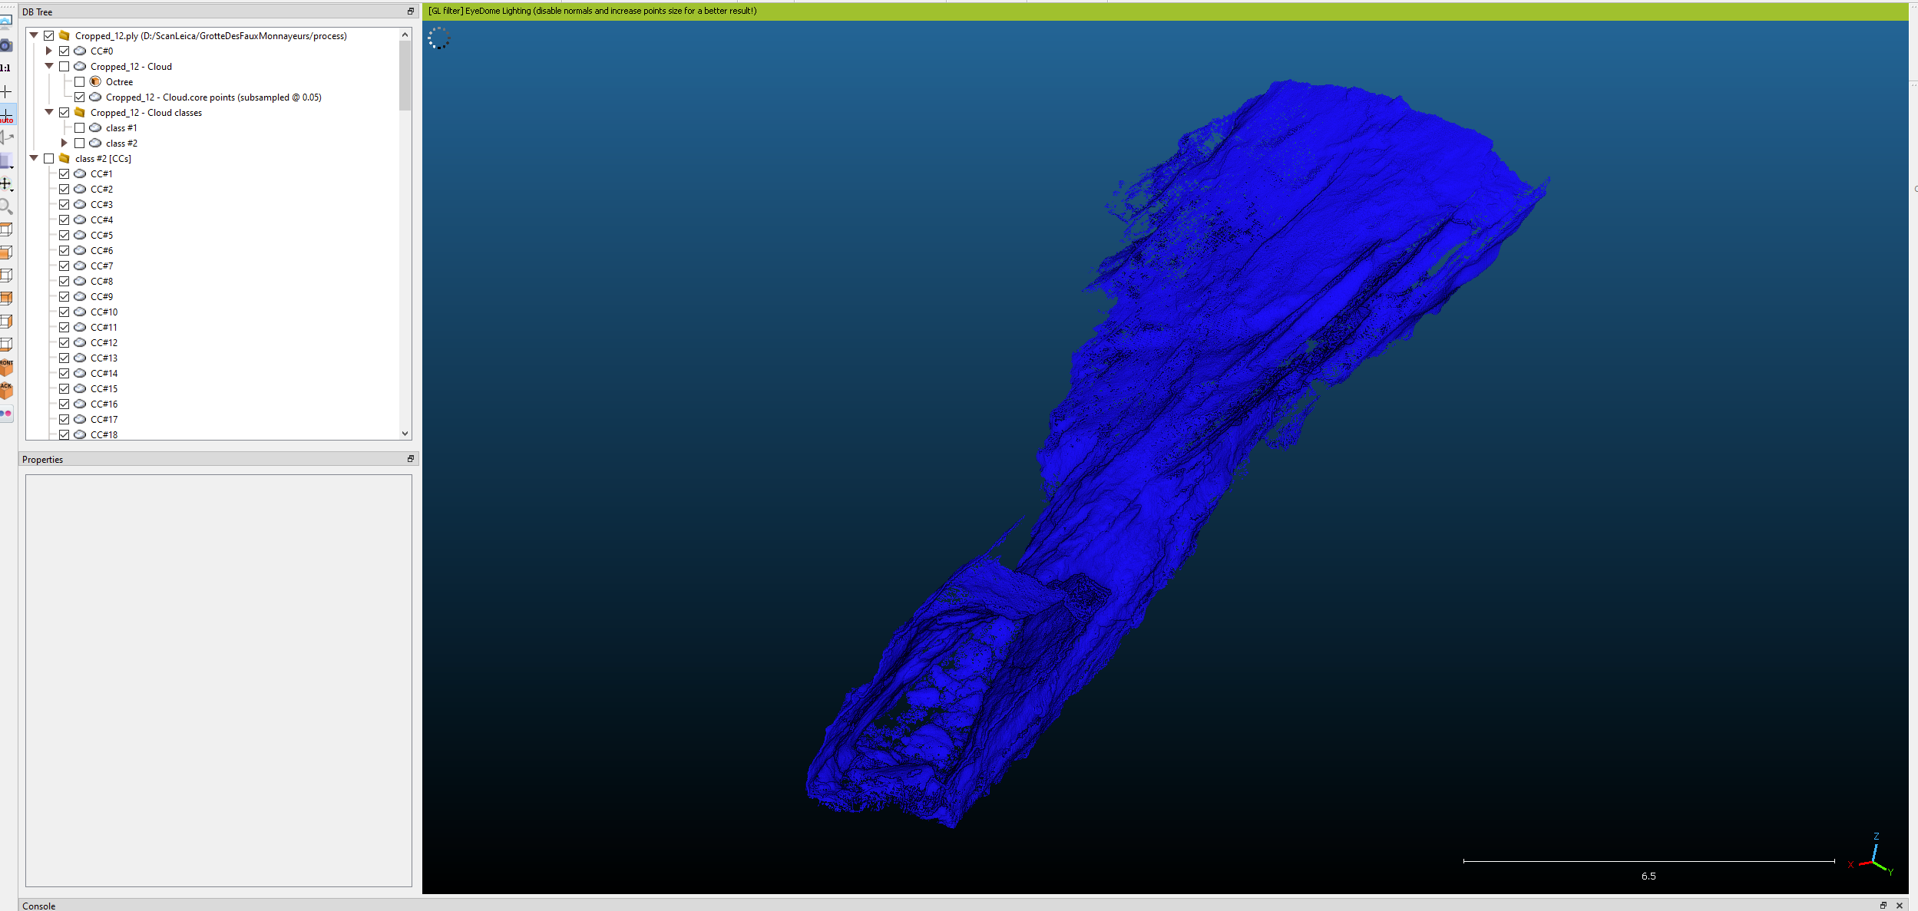

### Cropped 13

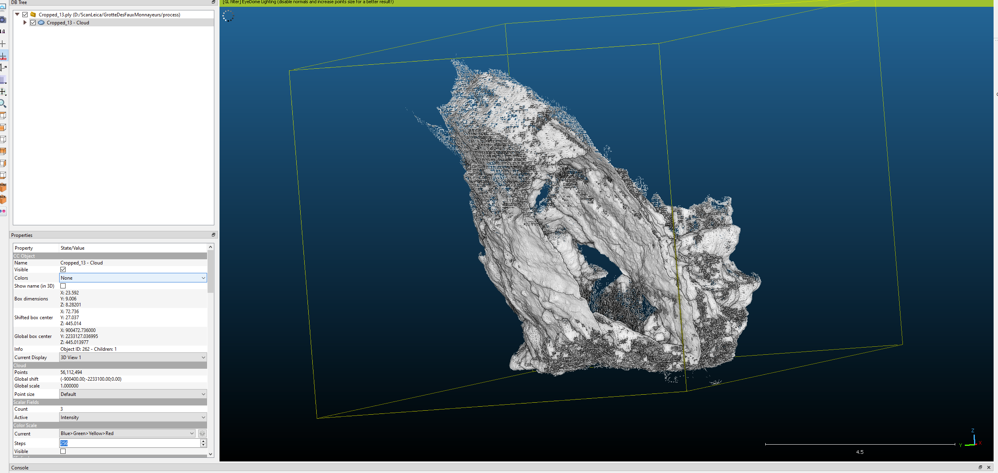

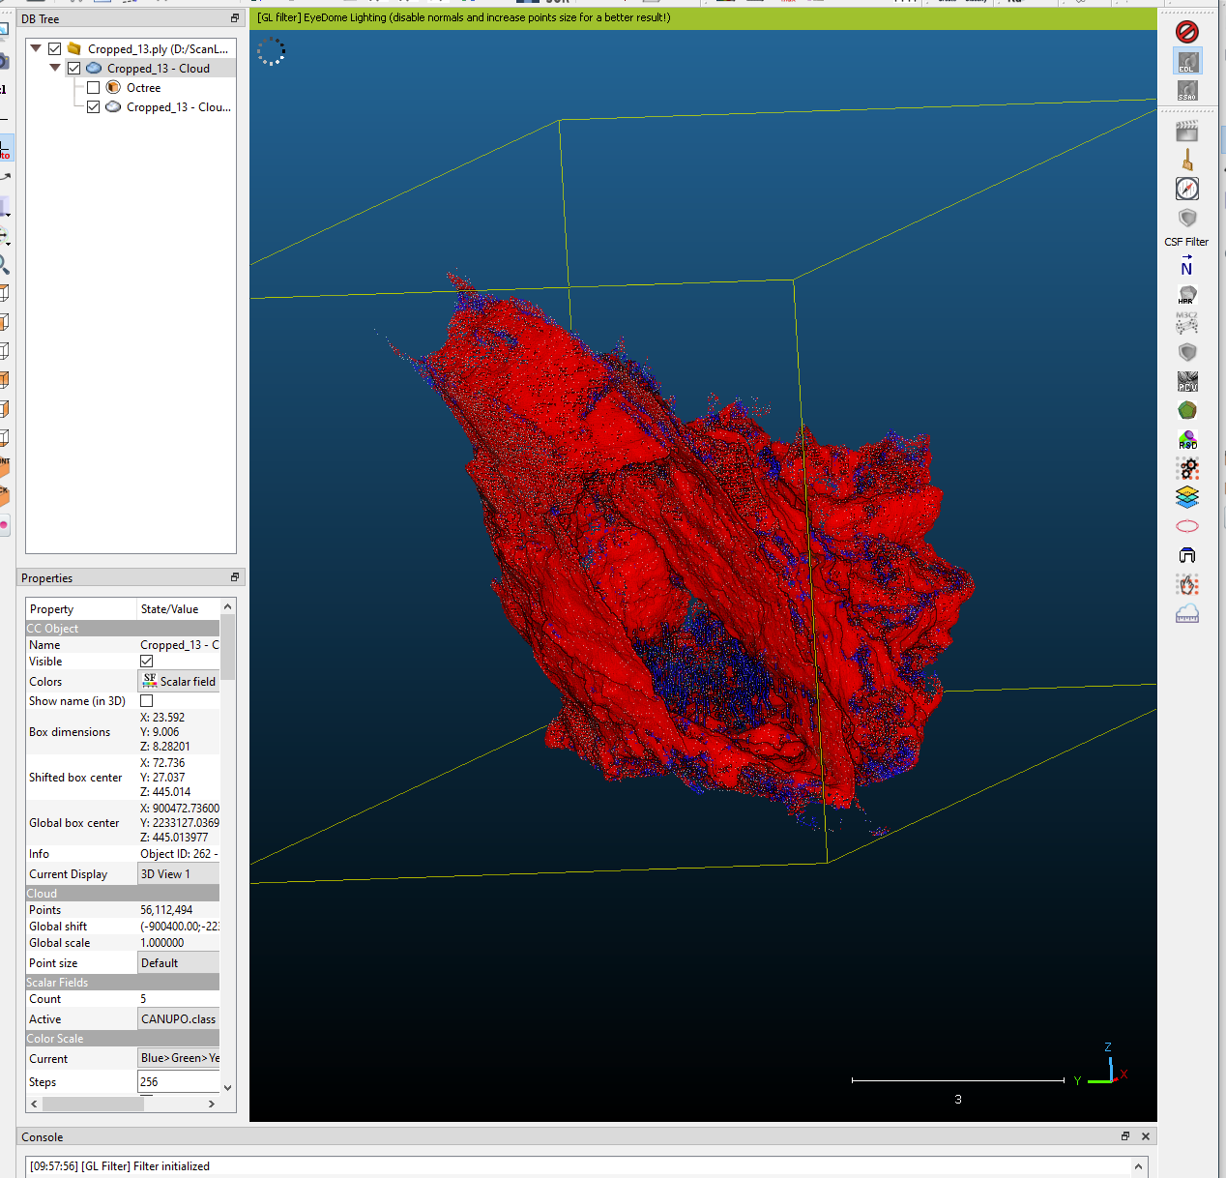

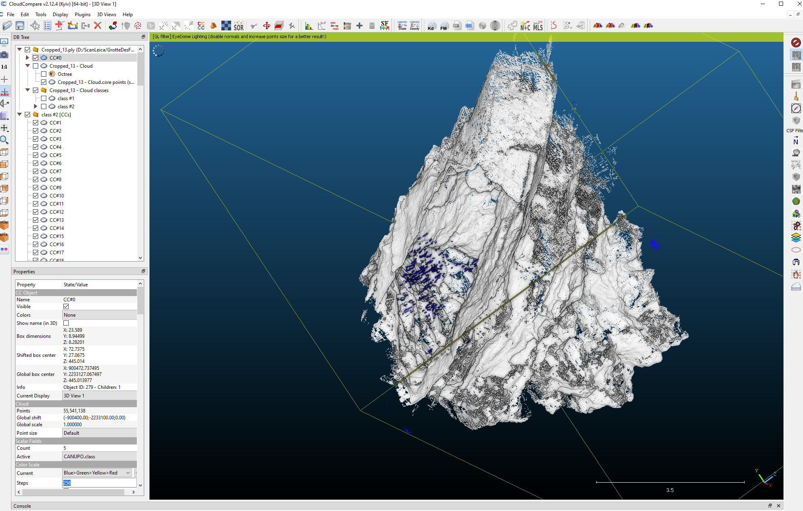

### Cropped 14

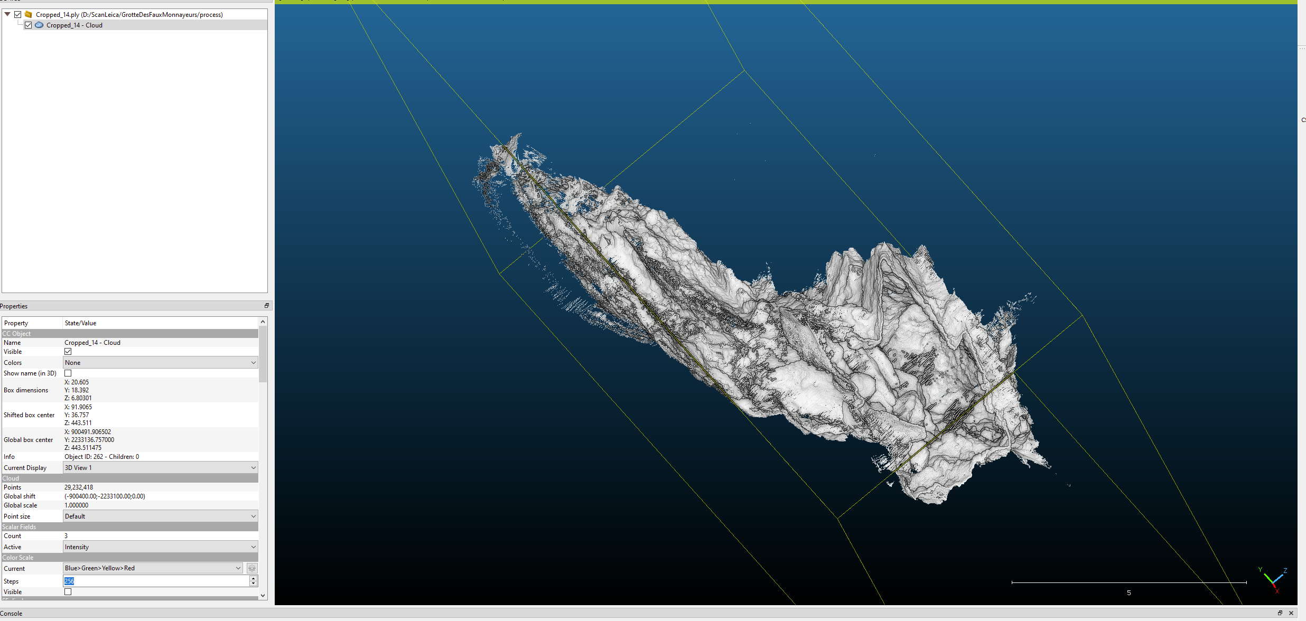

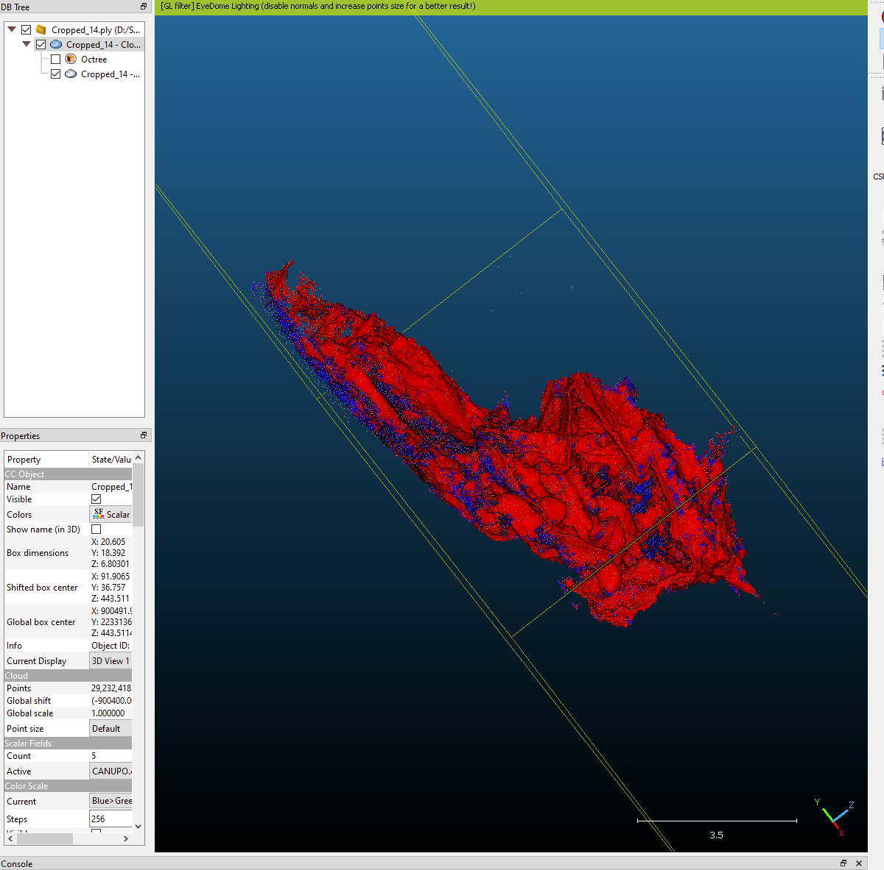

### Cropped 15

Reste des petits bouts d’opérateur

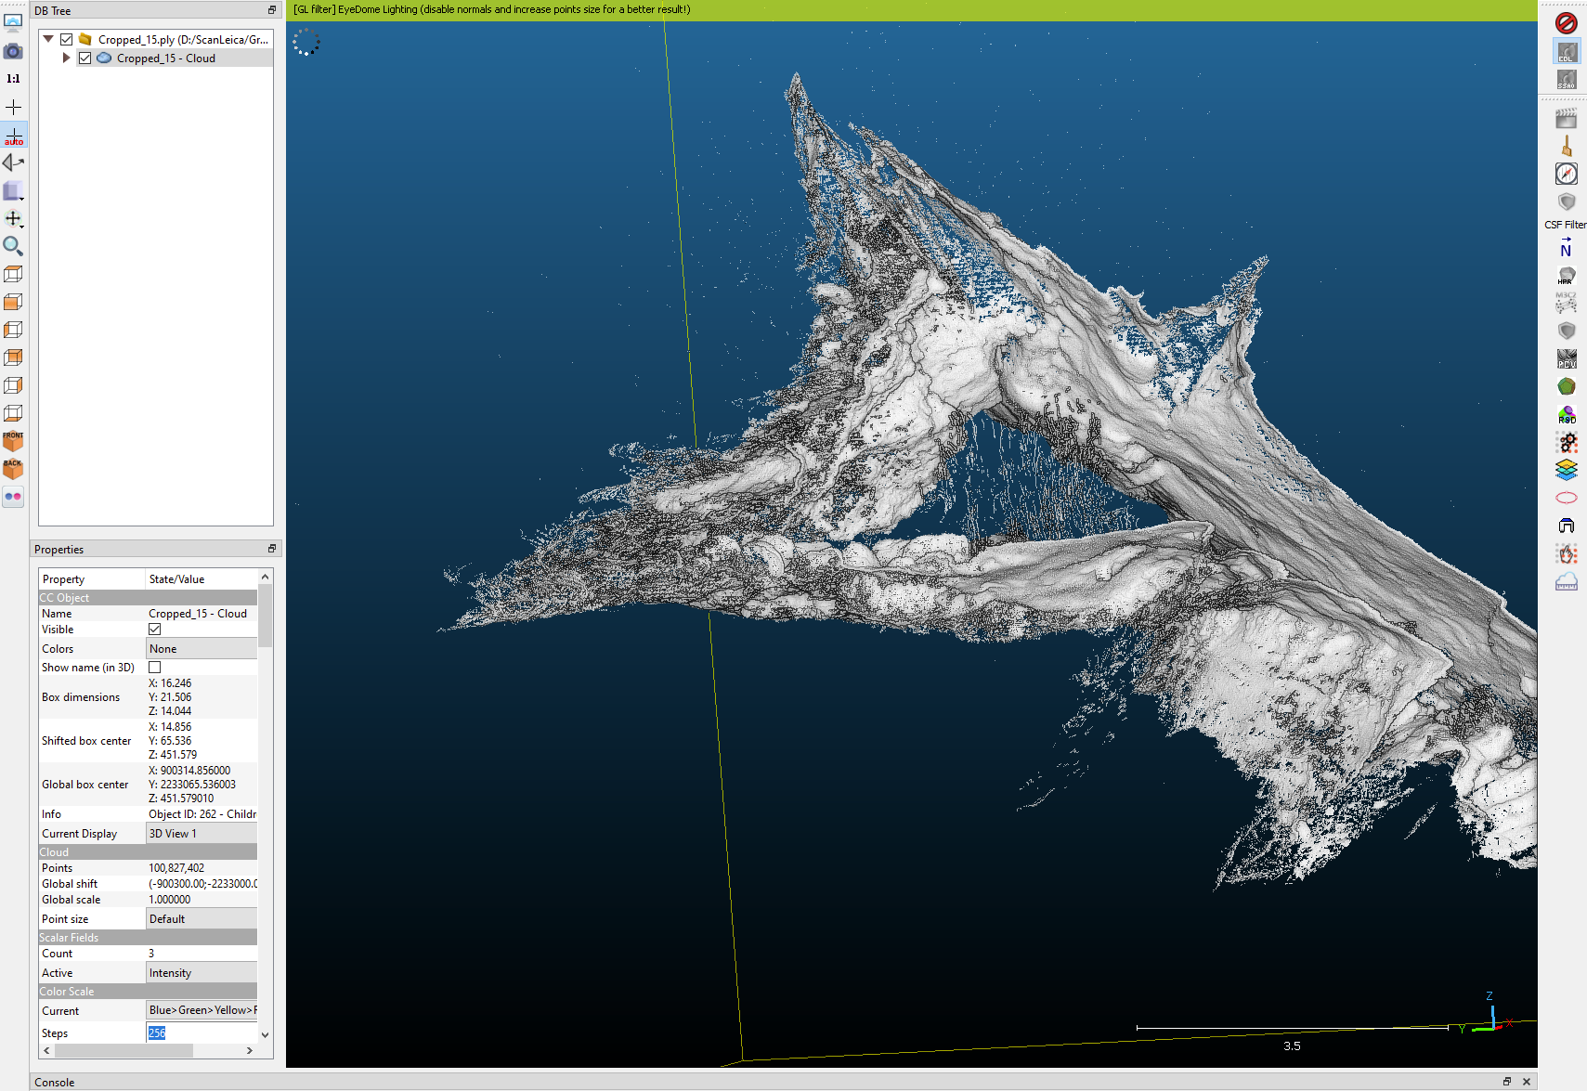

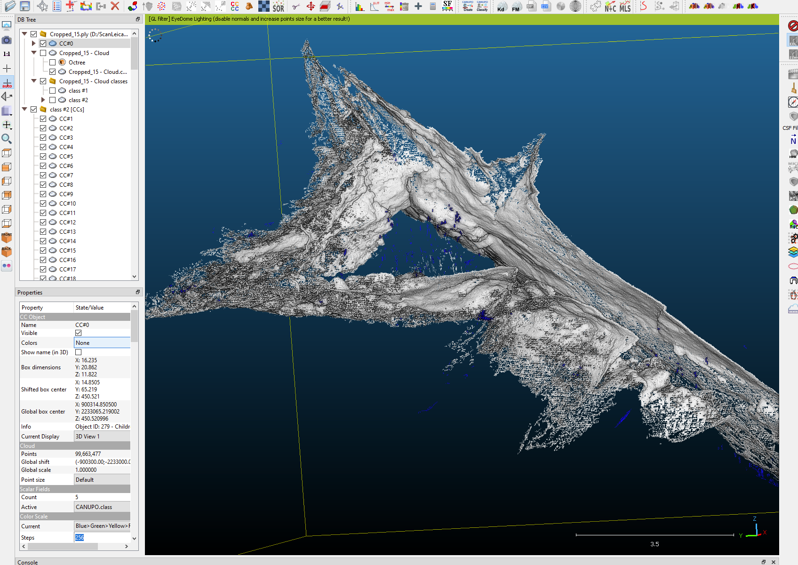

### Cropped 16

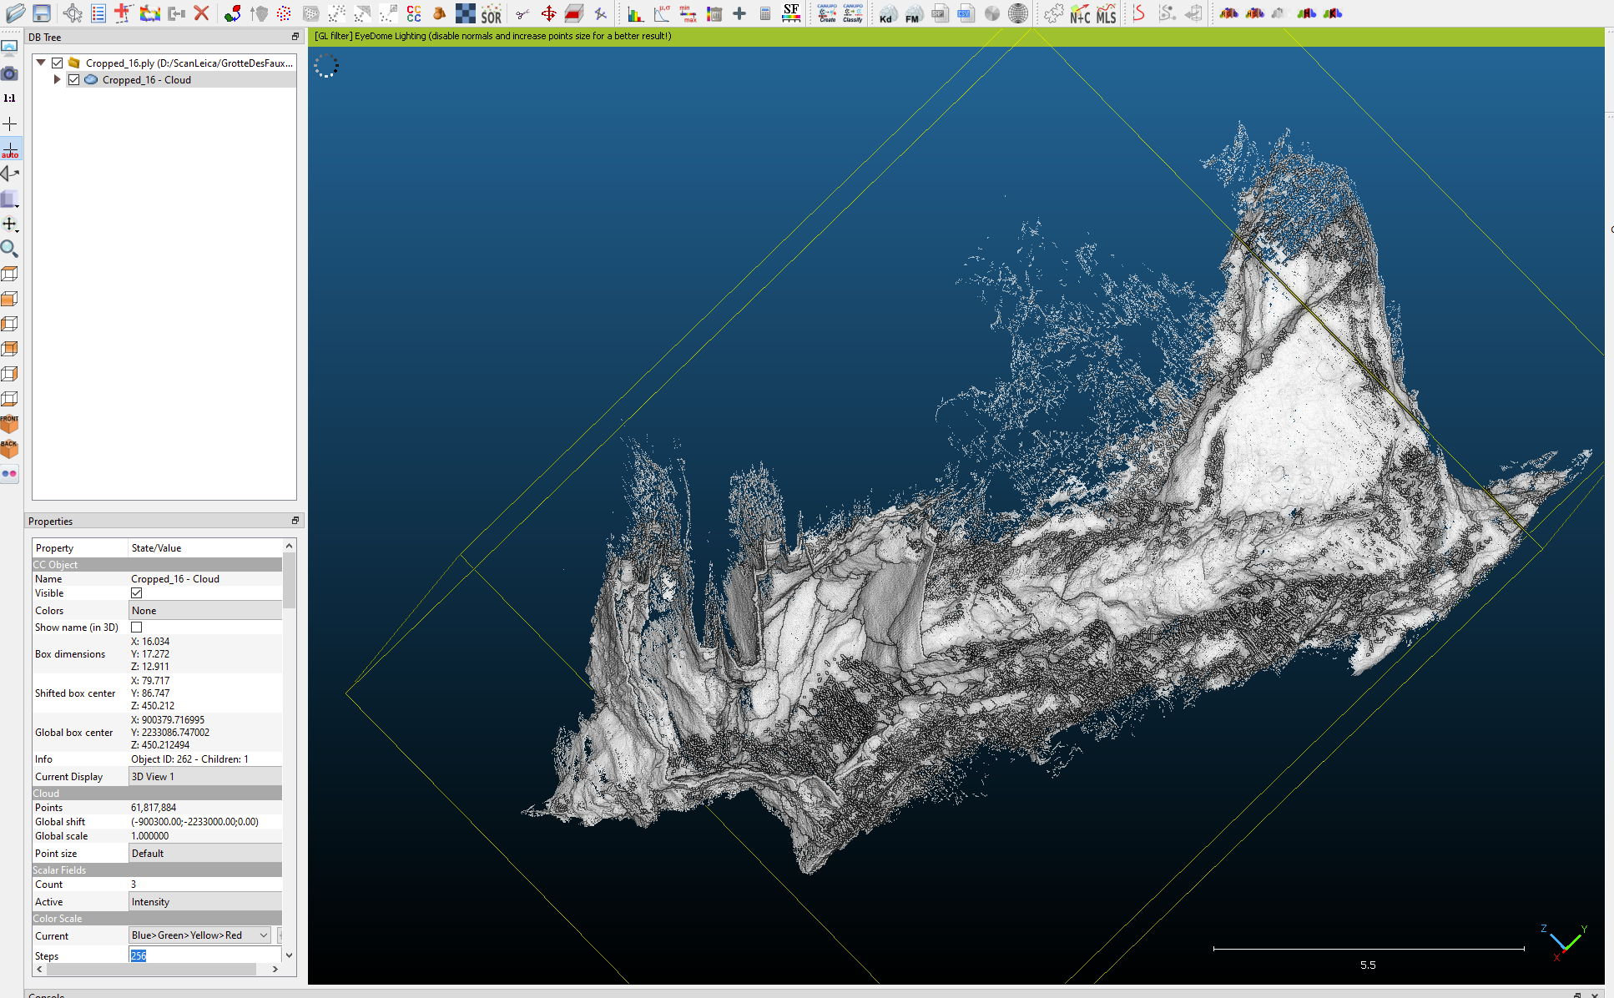

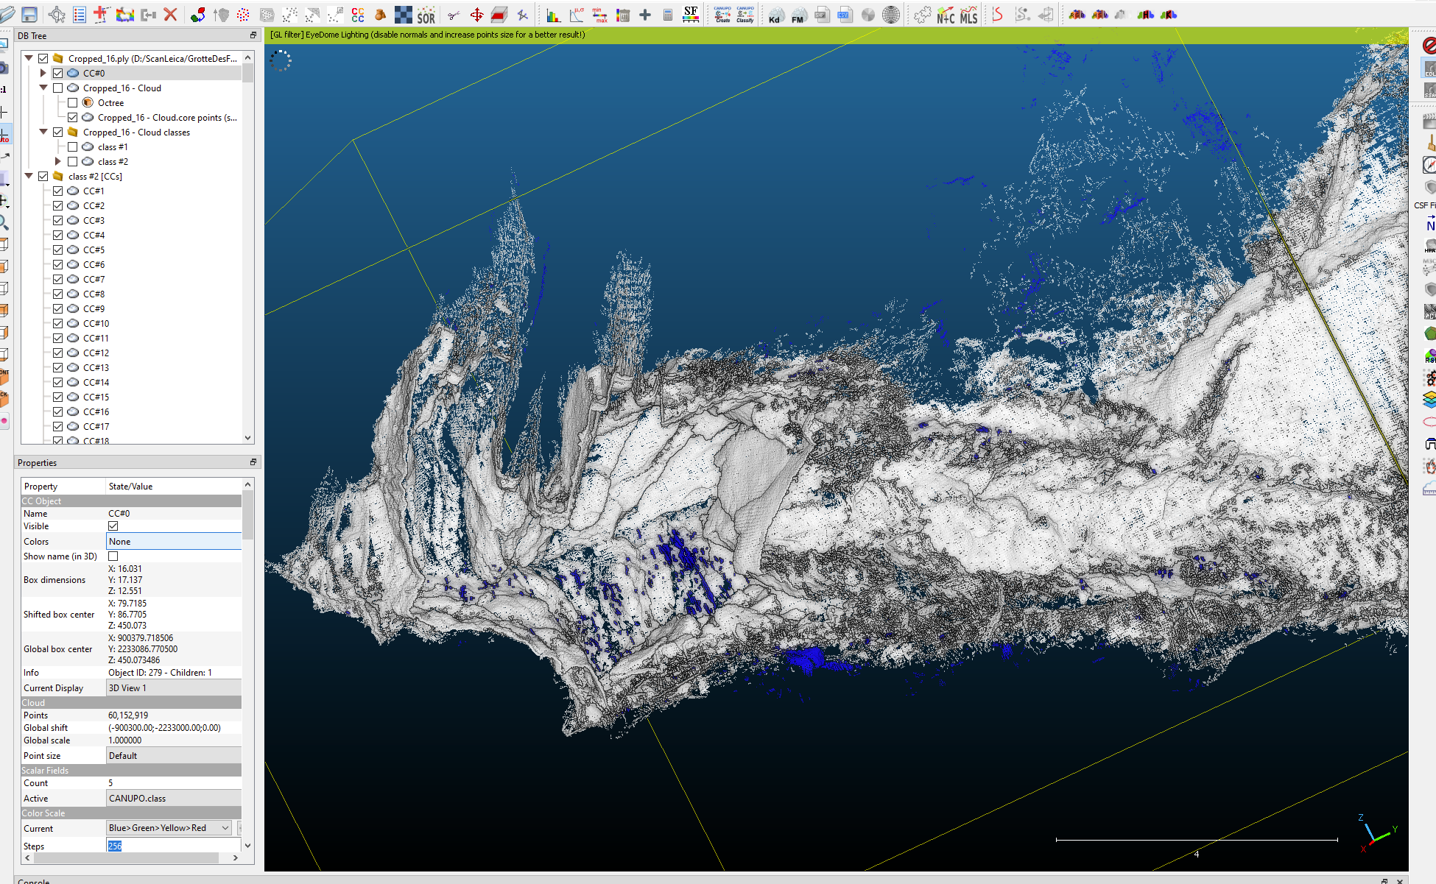

### Cropped 17

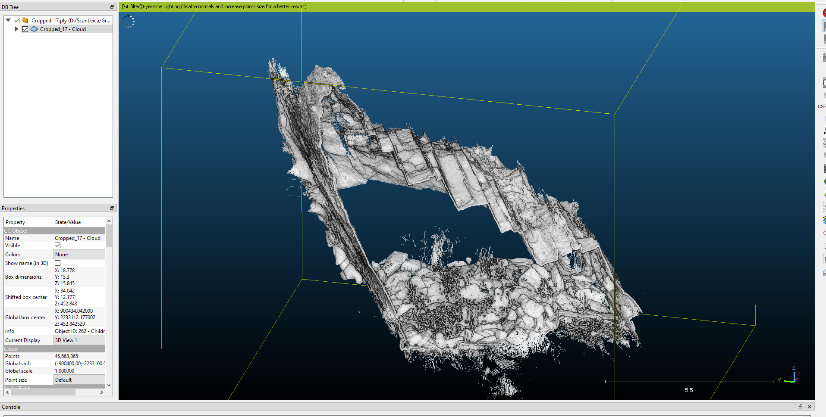

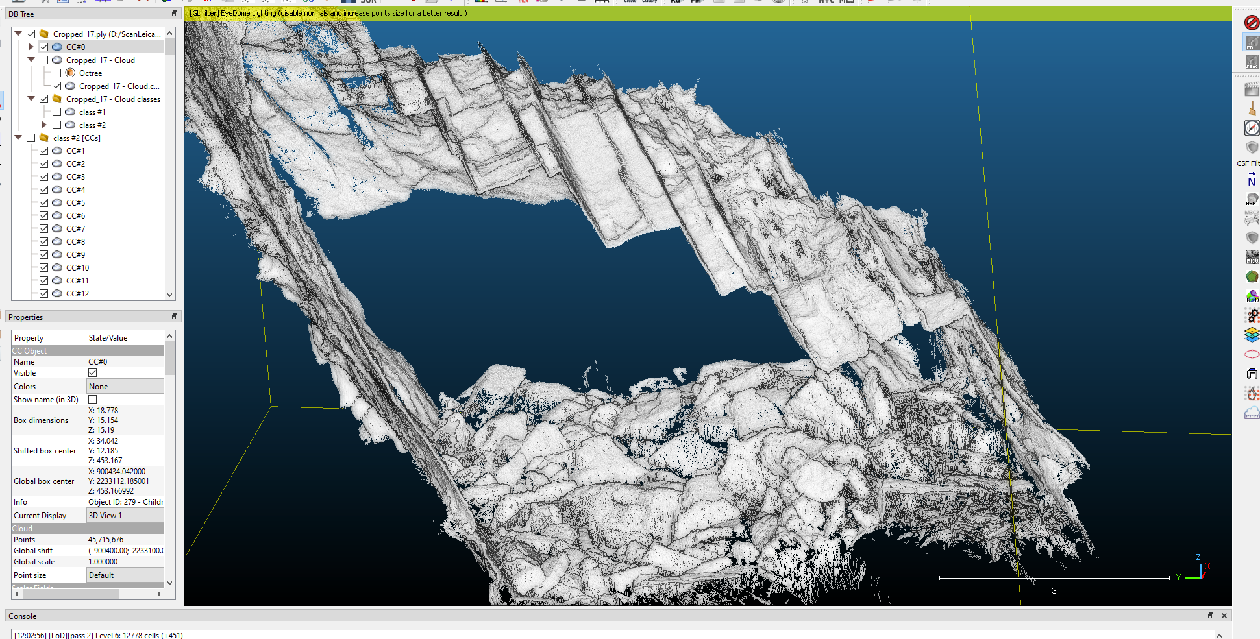

### Cropped 18

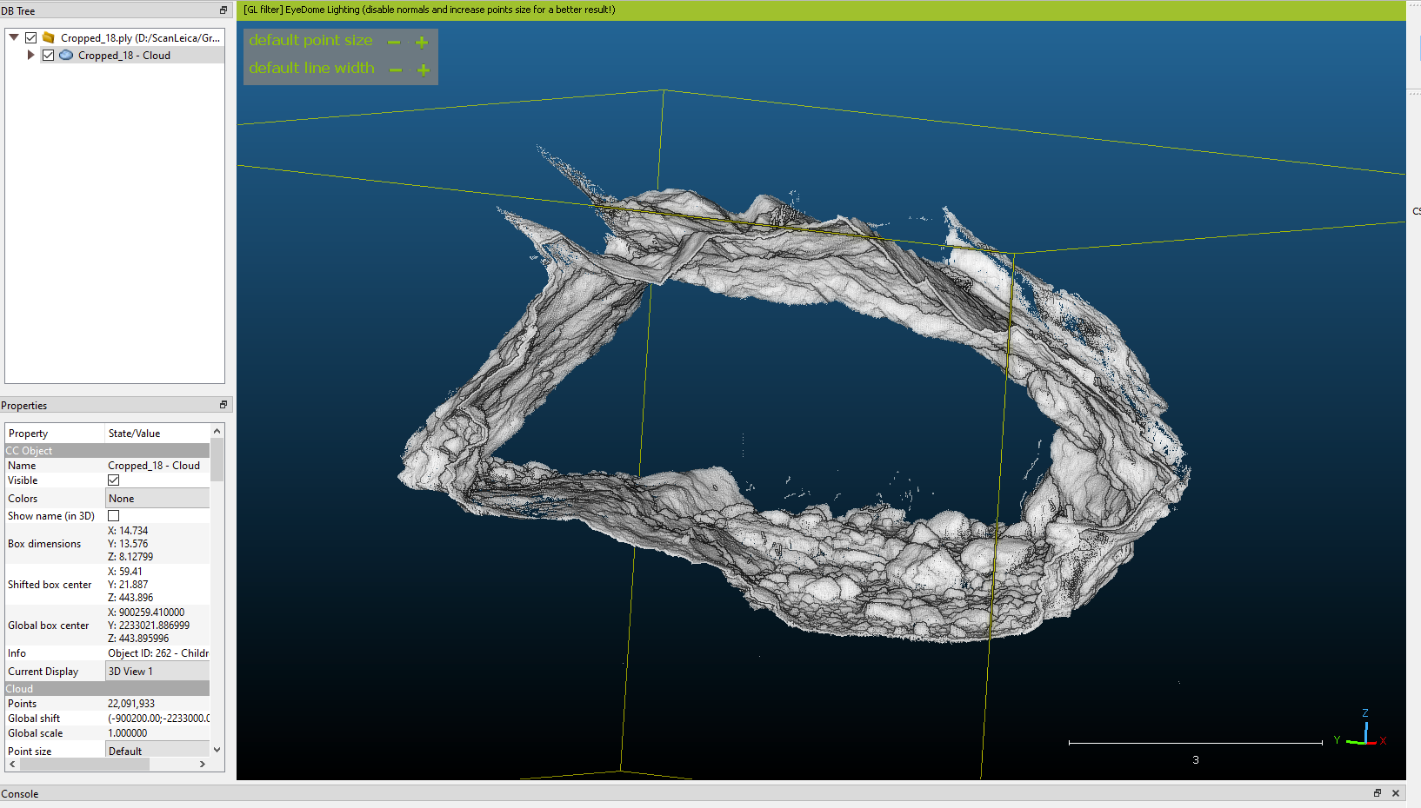

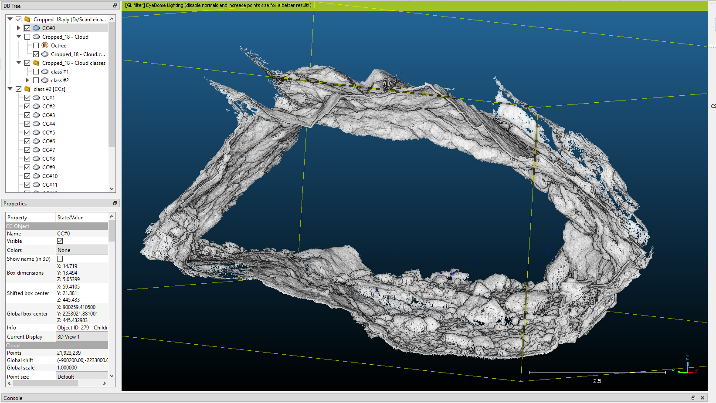

### Cropped 19

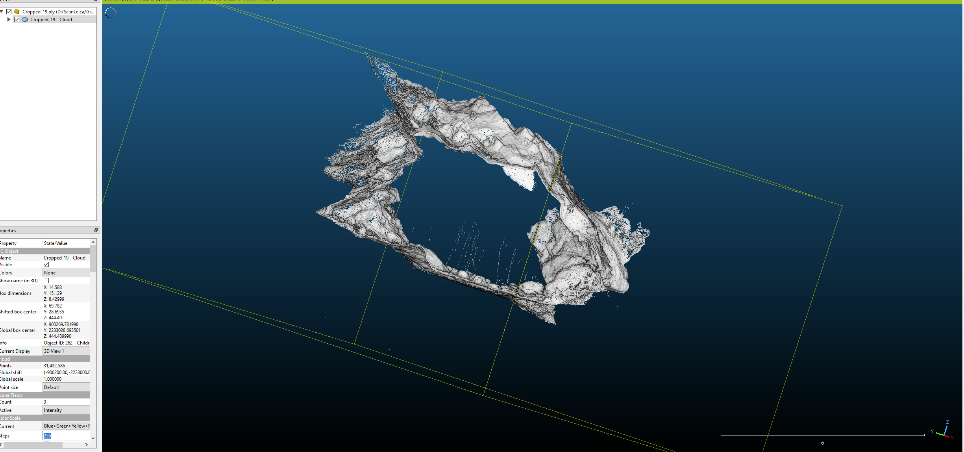

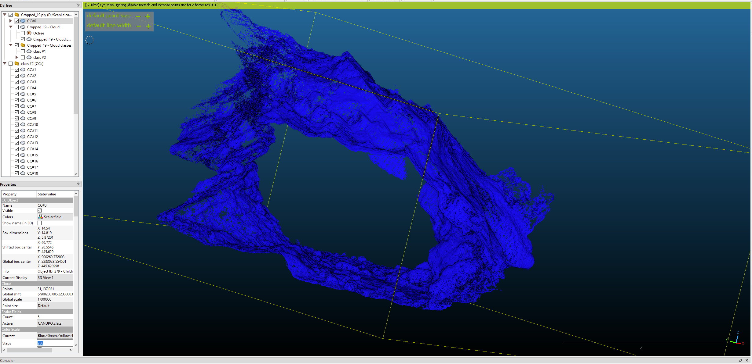

## 12.09.2023

Lorsque les opérateurs sont fixe, le classificateur n’est pas capable des les différencier completement de la roche. **Cropped 15, 9, 6, 2**

## 

On a tenté avec Tanguy d’entrainer un classificateur sur le cropped 2, mais le classificateur à enlever trop de points.

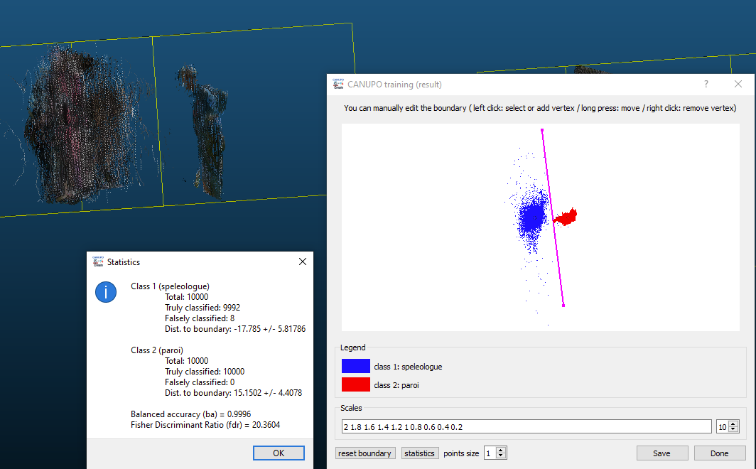

Nouvelle méthode. Pour les endroit ou il reste des points, enlever avec le ciseau.

1. Séparer provisoirement la zone d’intérêt pour faciliter le nettoyage.
   1. Got back to plan vue 
   2. Clic on the cisors icone  , select the portion with the operators, and clic on segment in 
   3. Select portions of the operator to remove without removing points from the cave, and segment out 
   4. Select the area of interest and the main part, and combine the two parts back together with  and answer no

## 13.09.2023

Cleaning up manually chunk 2 from operator before doing the connex componants. Doing the same with chunk 6.

Chunk 6 has an issue with the normal orientation of some of the parts. Strategy: reduce the chunk size and redo the normal calculations.

Chunk 15. There is some leftover operator. Strategy: redo the connex componants with a higher octree (smaller distance. In this case, octree=9, so 4cm)

Chunk 9... had to be broken up in different parts, separating the floor from the walls to enable accurate normals orientations. I used larger values of radius 0.36, and tried octree from 6-16 I think the reason is that the floor had a lot of big rocks and that the point cloud ended up being sparse between those rocks. Maybe in the future, make sure to scan areas like that more carefully.

Combining the entrance chunks 2,3,18,19,4,5 for the presentation VGC23.